**Practical No.: 01**

1. **Command line commands for modern networking**

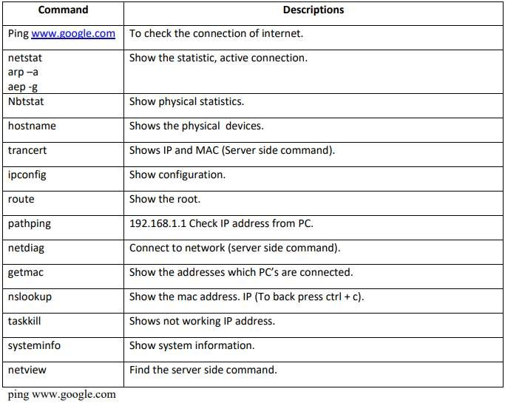

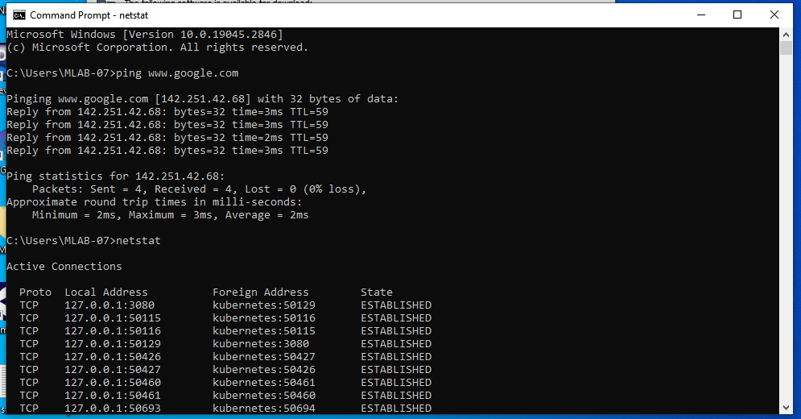

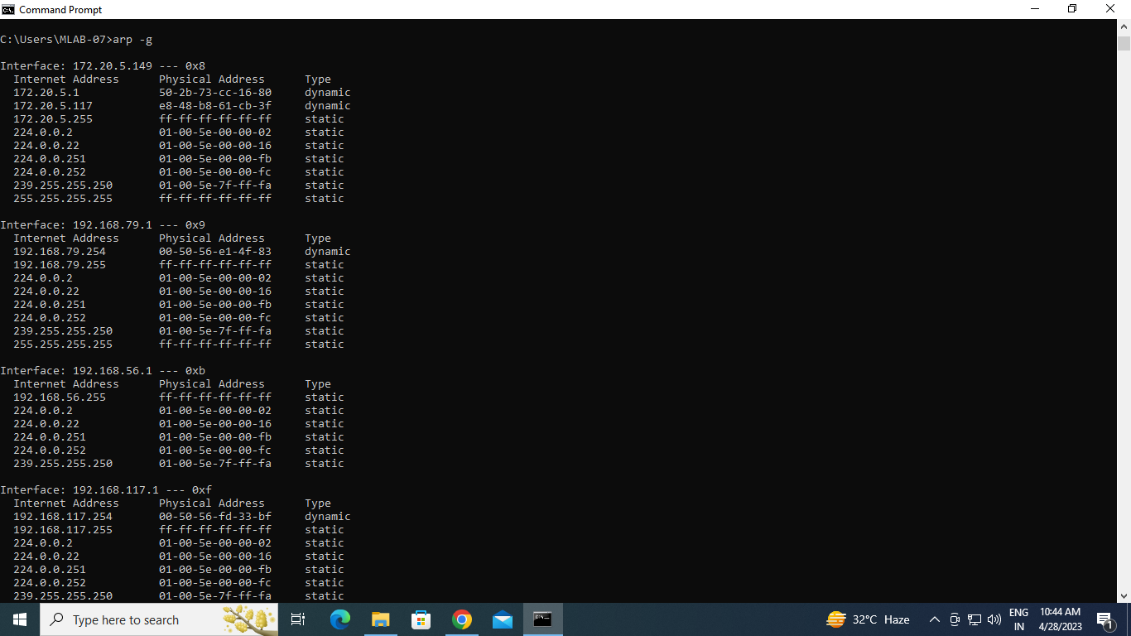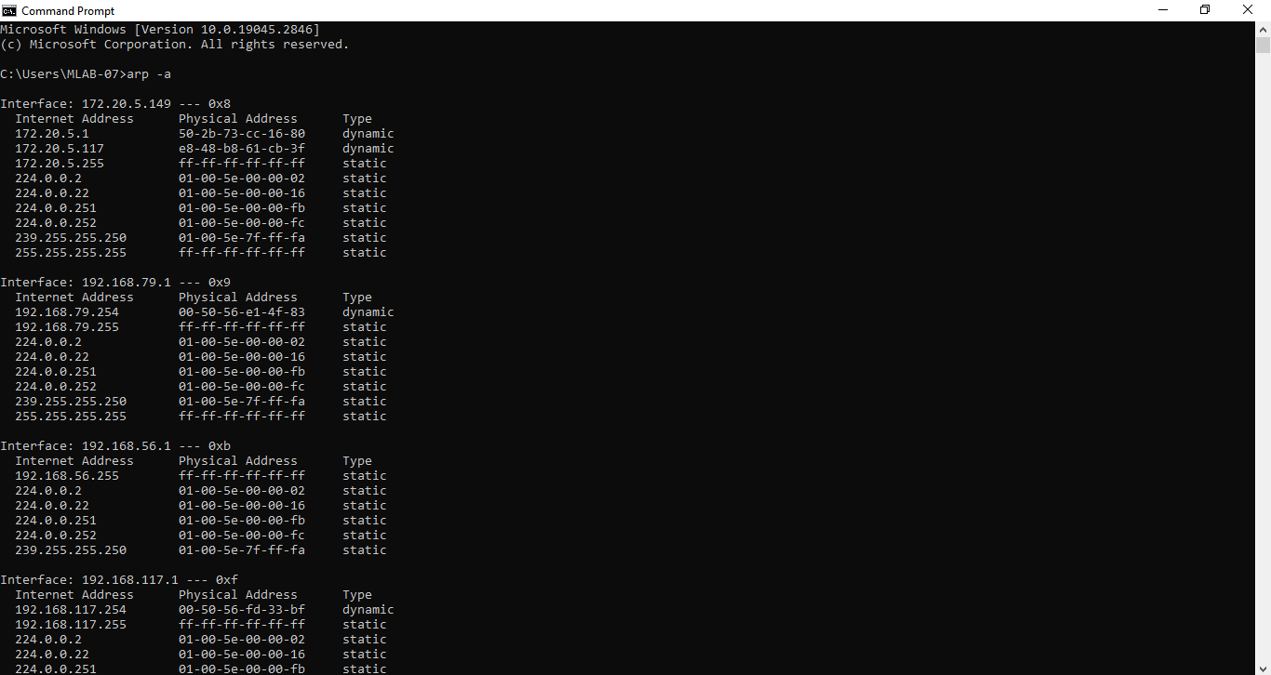

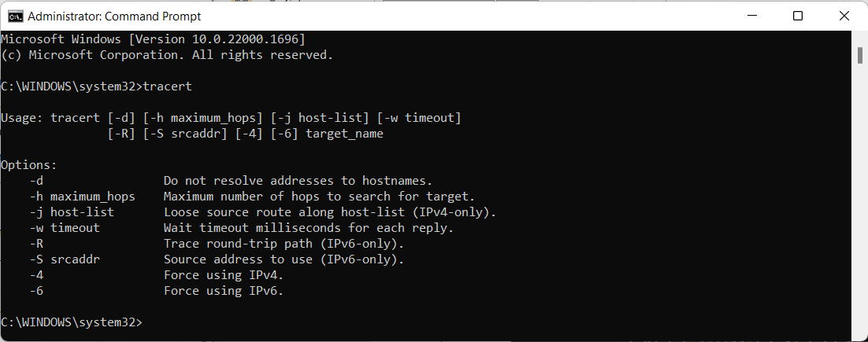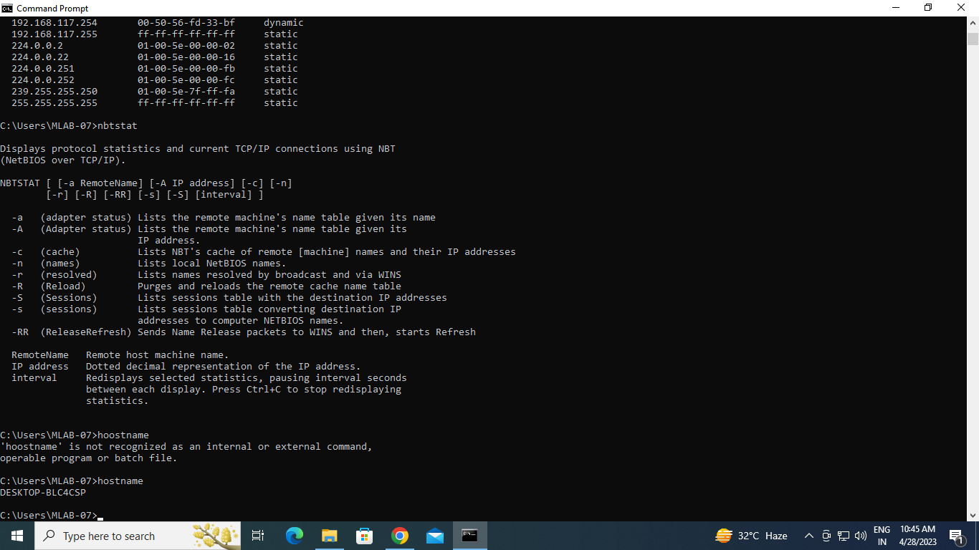

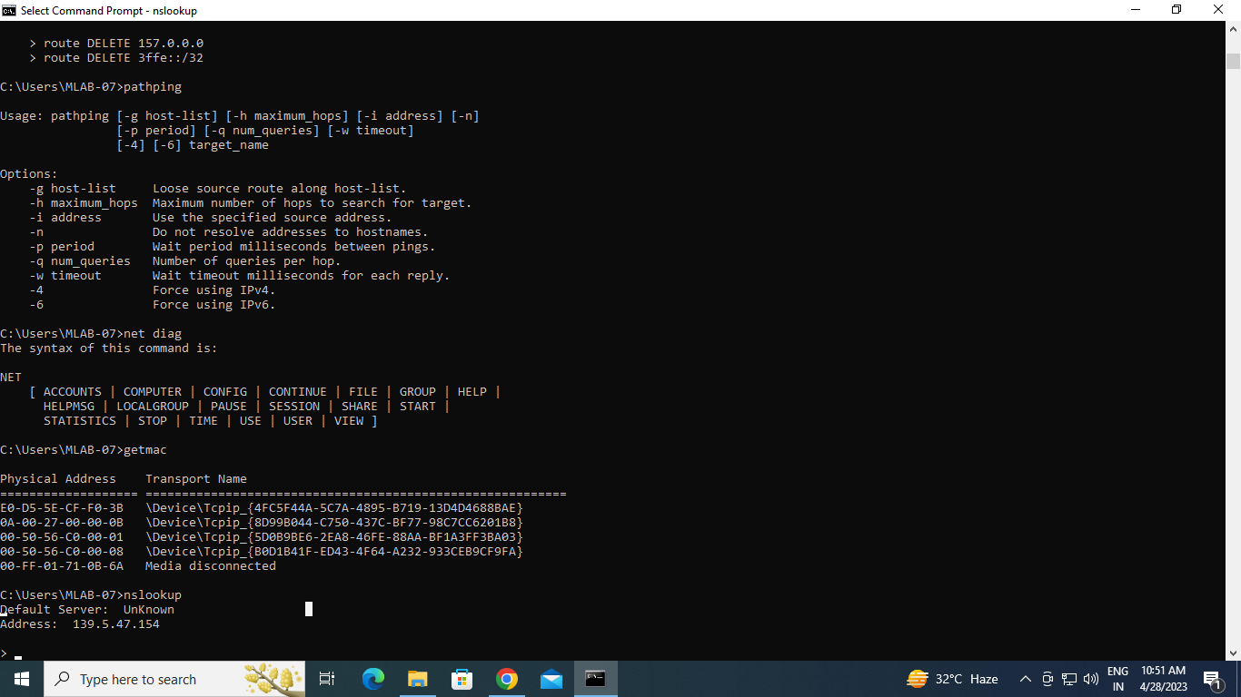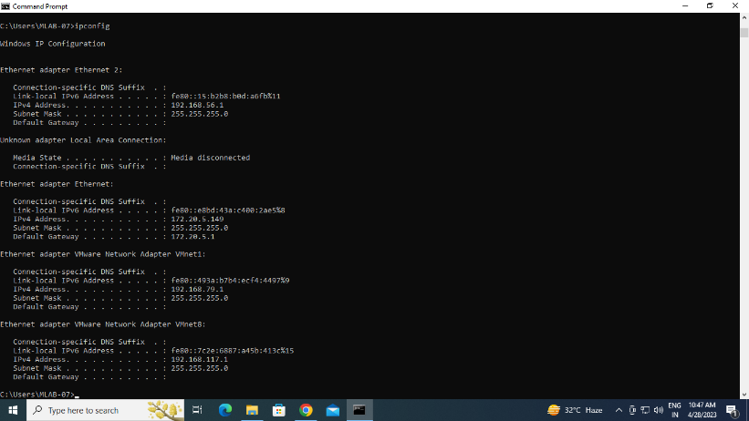

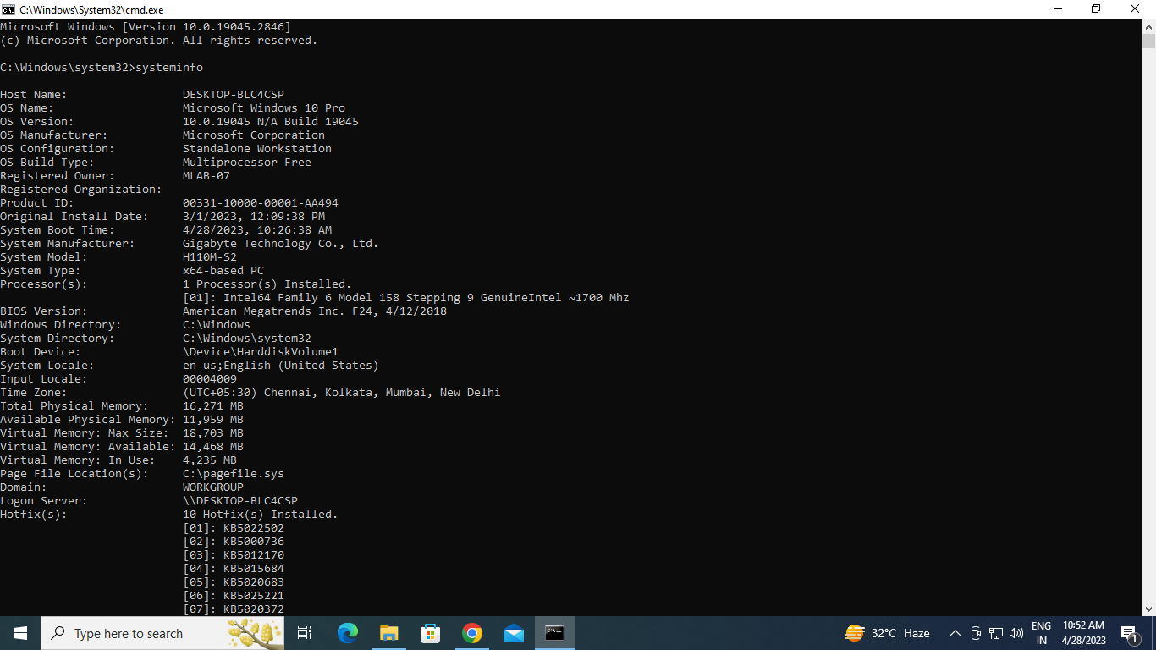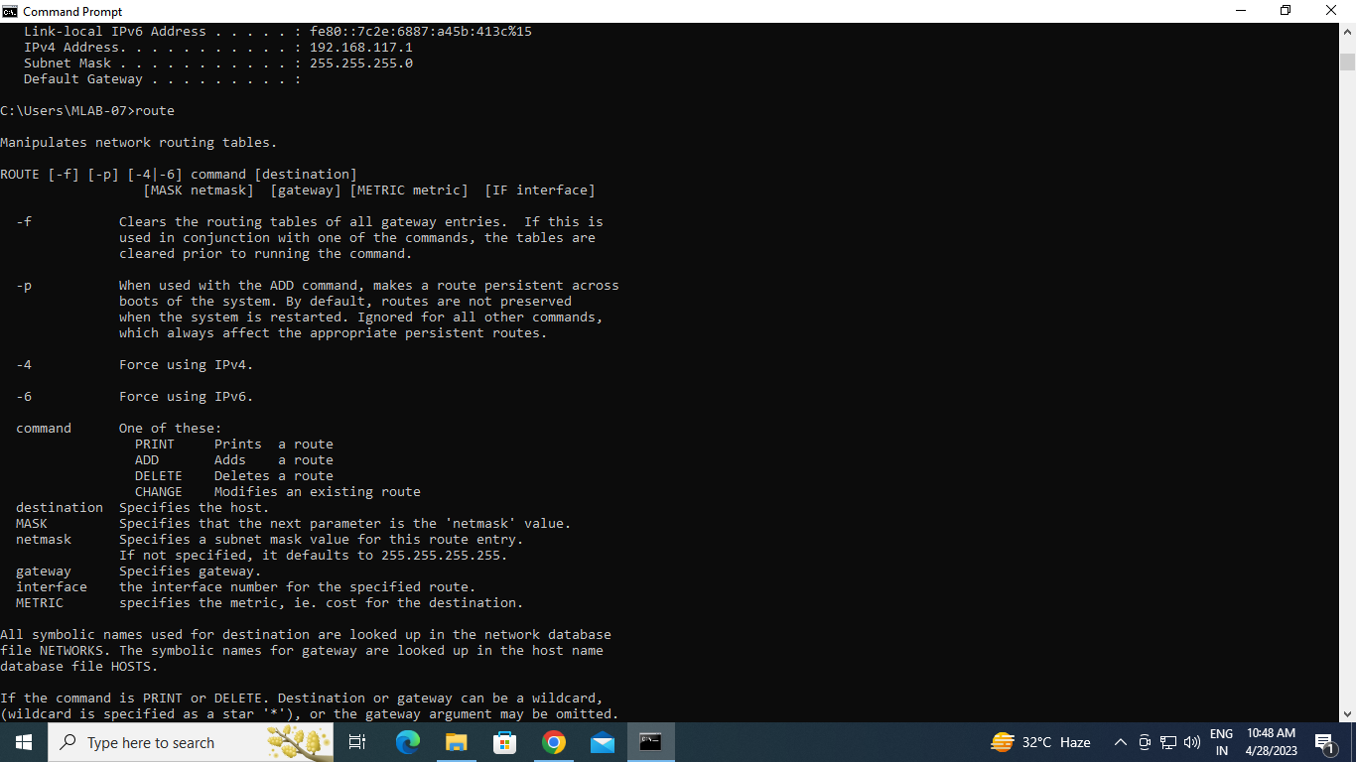

1. **Wi-Fi Hacking Password.**

* + 1. Open cmd with administrator mode.
    2. Type the command netsh wlan show profile → Shows nearby list of Wi- Fi connection.
    3. To check the password use the command → netsh wlan export profile folder = c:\ key=clear.
    4. The above command provides all the profile text file under c:\ drive.
    5. To verify/check the password → go to the c:\ drive → select any profile

→ under key Material XML tag → actual password.

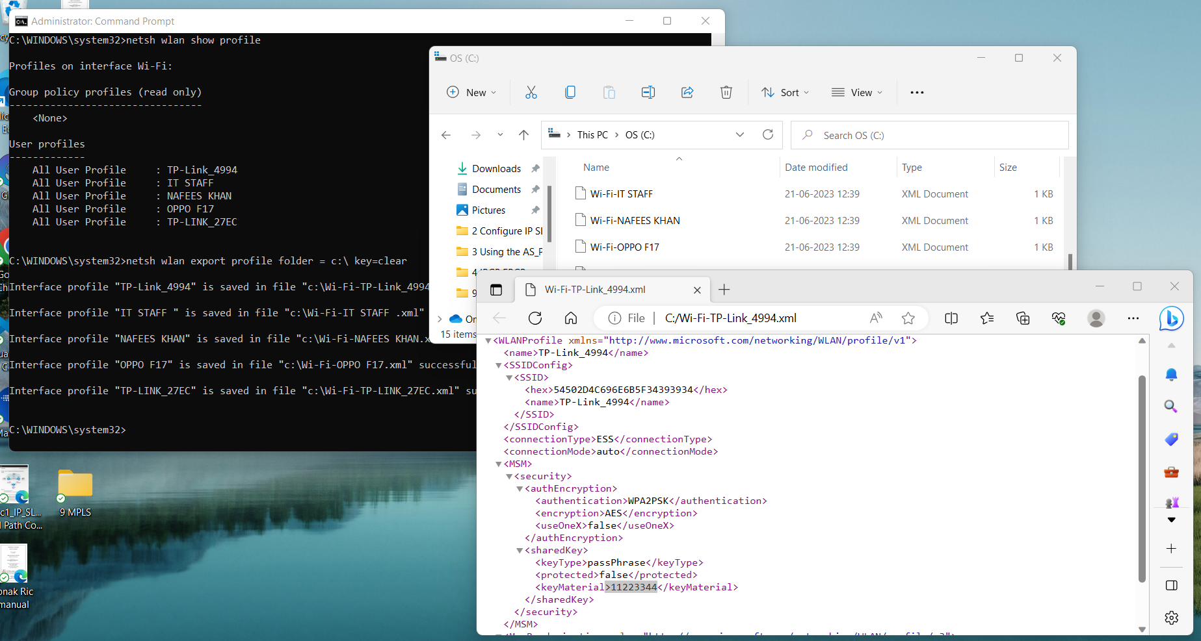

1. **Simple Packet Tracer.**

Two PC Connection Establishment:

1. Connects two or more different LAN’s.
2. It is a layer 3(Network layer) device.
3. Store routing table.
4. Router - Inevitable device in the internet.

**Process:**

1. Drag two switches (2960) for two local area networks.
2. Put 3 pc’s in each network.
3. Use Ethernet cable to connect the pc’s with the switches.

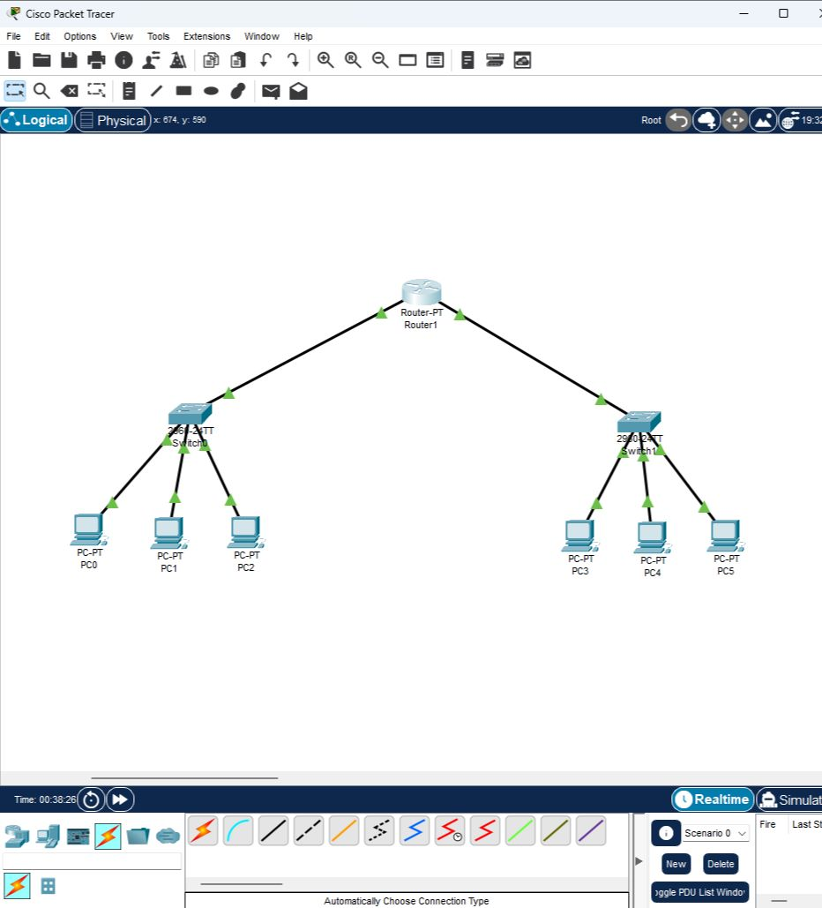

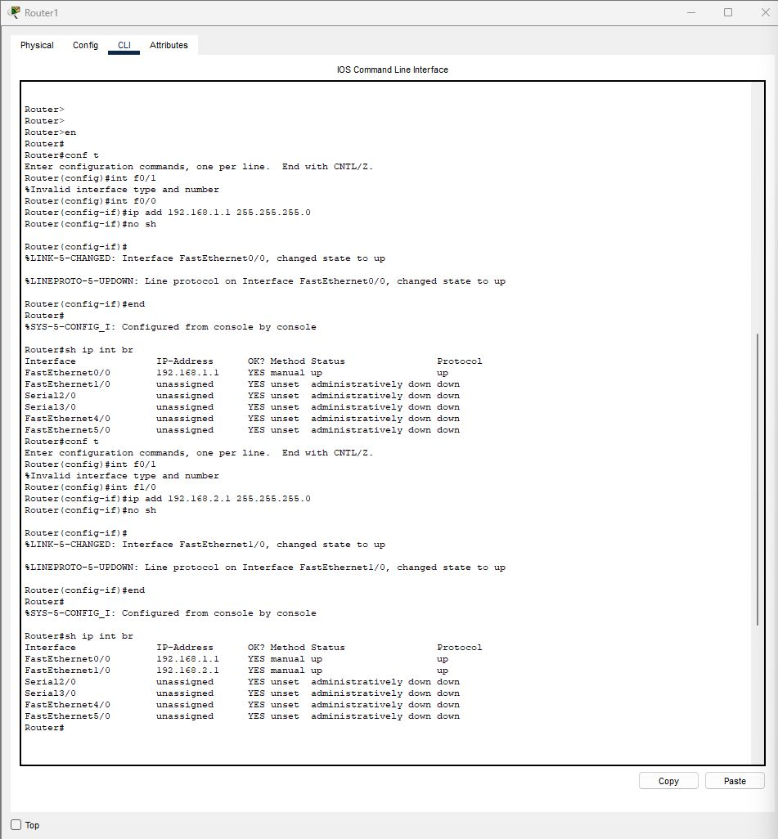

**Practical No.: 02**

**Configure IP SLA Tracking and Path Control**

**Topology:**

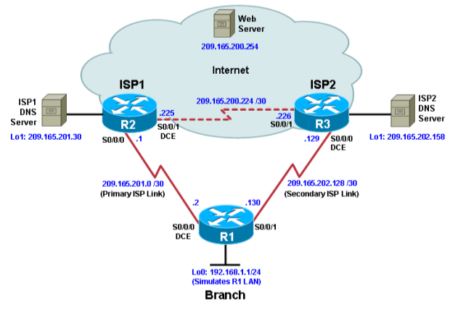

**Objectives:**

• Configure and verify the IP SLA feature.

• Test the IP SLA tracking feature.

• Verify the configuration and operation using show and debug commands.

**Step 1: Prepare the routers and configure the router hostname and interface addresses.**

1. **Using the addressing scheme in the diagram, create the loopback interfaces and apply IP addresses to them as well as the serial interfaces on R1, ISP1, and ISP2.**

**Router R1**

hostname R1

interface Loopback 0

 description R1 LAN

 ip address 192.168.1.1 255.255.255.0

interface Serial0/0/0

 description R1 --> ISP1

 ip address 209.165.201.2 255.255.255.252

 clock rate 128000

 bandwidth 128

 no shutdown

interface Serial0/0/1

 description R1 --> ISP2

 ip address 209.165.202.130 255.255.255.252

 bandwidth 128

 no shutdown

**Router ISP1 (R2)**

hostname ISP1

interface Loopback0

 description Simulated Internet Web Server

 ip address 209.165.200.254 255.255.255.255

interface Loopback1

 description ISP1 DNS Server

 ip address 209.165.201.30 255.255.255.255

interface Serial0/0/0

 description ISP1 --> R1

 ip address 209.165.201.1 255.255.255.252

 bandwidth 128

 no shutdown

interface Serial0/0/1

 description ISP1 --> ISP2

 ip address 209.165.200.225 255.255.255.252

 clock rate 128000

 bandwidth 128

 no shutdown

**Router ISP2 (R3)**

hostname ISP2

interface Loopback0

 description Simulated Internet Web Server

 ip address 209.165.200.254 255.255.255.255

interface Loopback1

 description ISP2 DNS Server

 ip address 209.165.202.158 255.255.255.255

interface Serial0/0/0

 description ISP2 --> R1

 ip address 209.165.202.129 255.255.255.252

 clock rate 128000

 bandwidth 128

 no shutdown

interface Serial0/0/1

 description ISP2 --> ISP1

 ip address 209.165.200.226 255.255.255.252

 bandwidth 128

 no shutdown

1. **Verify the configuration by using the show interfaces description command. The output from router R1 is shown here as an example.**

R1# **show interfaces description | include up**

Se0/0/0                        up             up       R1 --> ISP1

Se0/0/1                        up             up       R1 --> ISP2

Lo0                              up             up       R1 LAN

R1#

All three interfaces should be active. Troubleshoot if necessary.

**Step 2: Configure static routing.**

1. **Implement the routing policies on the respective routers. You can copy and paste the following configurations.**

**Router R1**

R1(config)# **ip route 0.0.0.0 0.0.0.0 209.165.201.1**

R1(config)#

**Router ISP1 (R2)**

ISP1(config)# **router eigrp 1**

ISP1(config-router)# **network 209.165.200.224 0.0.0.3**

ISP1(config-router)# **network 209.165.201.0 0.0.0.31**

ISP1(config-router)# **no auto-summary**

ISP1(config-router)# **exit**

ISP1(config)#

ISP1(config-router)# **ip route 192.168.1.0 255.255.255.0 209.165.201.2**

ISP1(config)#

**Router ISP2 (R3)**

ISP2(config)# **router eigrp 1**

ISP2(config-router)# **network 209.165.200.224 0.0.0.3**

ISP2(config-router)# **network 209.165.202.128 0.0.0.31**

ISP2(config-router)# **no auto-summary**

ISP2(config-router)# **exit**

ISP2(config)#

ISP2(config)# **ip route 192.168.1.0 255.255.255.0 209.165.202.130**

ISP2(config)#

1. **From router R1, ping the web server, ISP1 DNS server, and ISP2 DNS server to verify connectivity. You can copy the following Tcl script and paste it into R1.**

R1#**tclsh**

R1(tcl)#foreach address {

+>(tcl)#209.165.200.254

+>(tcl)#209.165.201.30

+>(tcl)#209.165.202.158

+>(tcl)#} {

+>(tcl)#ping $address source 192.168.1.1

+>(tcl)#}

Type escape sequence to abort.

Sending 5, 100-byte ICMP Echos to 209.165.200.254, timeout is 2 seconds:

Packet sent with a source address of 192.168.1.1

!!!!!

Success rate is 100 percent (5/5), round-trip min/avg/max = 32/36/52 ms

Type escape sequence to abort.

Sending 5, 100-byte ICMP Echos to 209.165.201.30, timeout is 2 seconds:

Packet sent with a source address of 192.168.1.1

!!!!!

Success rate is 100 percent (5/5), round-trip min/avg/max = 24/28/36 ms

Type escape sequence to abort.

Sending 5, 100-byte ICMP Echos to 209.165.202.158, timeout is 2 seconds:

Packet sent with a source address of 192.168.1.1

!!!!!

Success rate is 0 percent (0/5)

1. **Before implementing the Cisco IOS SLA feature, you must verify reachability to the Internet servers. From router R1, ping the web server, ISP1 DNS server, and ISP2 DNS server to verify connectivity. You can copy the following Tcl script and paste it into R1.**

R1(tcl)#foreach address {

+>(tcl)#209.165.200.254

+>(tcl)#209.165.201.30

+>(tcl)#209.165.202.158

+>(tcl)#} {

+>(tcl)#trace $address source 192.168.1.1

+>(tcl)#}

Type escape sequence to abort.

Tracing the route to 209.165.200.254

VRF info: (vrf in name/id, vrf out name/id)

1 209.165.201.1 76 msec 48 msec 28 msec

Type escape sequence to abort.

Tracing the route to 209.165.201.30

VRF info: (vrf in name/id, vrf out name/id)

1 209.165.201.1 36 msec 16 msec 28 msec

Type escape sequence to abort.

Tracing the route to 209.165.202.158

VRF info: (vrf in name/id, vrf out name/id)

1 209.165.201.1 20 msec 28 msec 24 msec

2 209.165.201.1

R1(tcl)#exit

**Step 3: Configure IP SLA probes.**

1. **Create an ICMP echo probe on R1 to the primary DNS server on ISP1 using the ip sla command.**

R1(config)# **ip sla 11**

R1(config-ip-sla)# **icmp-echo 209.165.201.30**

R1(config-ip-sla-echo)# **frequency 10**

R1(config-ip-sla-echo)# **exit**

R1(config)#

R1(config)# **ip sla schedule 11 life forever start-time now**

R1(config)#

1. **Verify the IP SLAs configuration of operation 11 using the show ip sla configuration 11 command.**

R1# **show ip sla configuration 11**

IP SLAs Infrastructure Engine-III

Entry number: 11

Owner:

Tag:

Operation timeout (milliseconds): 5000

Type of operation to perform: icmp-echo

Target address/Source address: 209.165.201.30/0.0.0.0

Type Of Service parameter: 0x0

Request size (ARR data portion): 28

Verify data: No

Vrf Name:

Schedule:

Operation frequency (seconds): 10 (not considered if randomly scheduled)

Next Scheduled Start Time: Start Time already passed

Group Scheduled : FALSE

Randomly Scheduled : FALSE

Life (seconds): Forever

Entry Ageout (seconds): never

Recurring (Starting Everyday): FALSE

Status of entry (SNMP RowStatus): Active

Threshold (milliseconds): 5000

Distribution Statistics:

Number of statistic hours kept: 2

1. **Issue the show ip sla statistics command to display the number of successes, failures, and results of the latest operations.**

R1# **show ip sla statistics**

IPSLAs Latest Operation Statistics

IPSLA operation id: 11

Latest RTT: 20 milliseconds

Latest operation start time: 22:11:07 UTC Tue Mar 21 2023

Latest operation return code: OK

Number of successes: 18

Number of failures: 0

Operation time to live: Forever

1. **Although not actually required because IP SLA session 11 alone could provide the desired fault tolerance, create a second probe, 22, to test connectivity to the second DNS server located on router ISP2.**

R1(config)# **ip sla 22**

R1(config-ip-sla)# **icmp-echo 209.165.202.158**

R1(config-ip-sla-echo)# **frequency 10**

R1(config-ip-sla-echo)# **exit**

R1(config)#

R1(config)# **ip sla schedule 22 life forever start-time now**

R1(config)# **end**

R1#

1. **Verify the new probe using the show ip sla configuration and show ip sla statistics commands.**

R1# **show ip sla configuration 22**

IP SLAs Infrastructure Engine-III

Entry number: 22

Owner:

Tag:

Operation timeout (milliseconds): 5000

Type of operation to perform: icmp-echo

Target address/Source address: 209.165.202.158/0.0.0.0

Type Of Service parameter: 0x0

Request size (ARR data portion): 28

Verify data: No

Vrf Name:

Schedule:

Operation frequency (seconds): 10 (not considered if randomly scheduled)

Next Scheduled Start Time: Start Time already passed

Group Scheduled : FALSE

Randomly Scheduled : FALSE

Life (seconds): Forever

Entry Ageout (seconds): never

Recurring (Starting Everyday): FALSE

Status of entry (SNMP RowStatus): Active

Threshold (milliseconds): 5000

Distribution Statistics:

Number of statistic hours kept: 2

Number of statistic distribution buckets kept: 1

R1# **show ip sla configuration 22**

IP SLAs Infrastructure Engine-III

Entry number: 22

Owner:

Tag:

Operation timeout (milliseconds): 5000

Type of operation to perform: icmp-echo

Target address/Source address: 209.165.202.158/0.0.0.0

Type Of Service parameter: 0x0

Request size (ARR data portion): 28

Verify data: No

Vrf Name:

Schedule:

Operation frequency (seconds): 10 (not considered if randomly scheduled)

Next Scheduled Start Time: Start Time already passed

Group Scheduled : FALSE

Randomly Scheduled : FALSE

Life (seconds): Forever

Entry Ageout (seconds): never

Recurring (Starting Everyday): FALSE

Status of entry (SNMP RowStatus): Active

Threshold (milliseconds): 5000

Distribution Statistics:

Number of statistic hours kept: 2

Number of statistic distribution buckets kept: 1

R1#

R1# **show ip sla statistics 22**

IPSLAs Latest Operation Statistics

IPSLA operation id: 22

Latest RTT: NoConnection/Busy/Timeout

Latest operation start time: 22:16:37 UTC Tue Mar 21 2023

Latest operation return code: Timeout

Number of successes: 0

Number of failures: 11

Operation time to live: Forever

R1#

**Step 4: Configure tracking options.**

1. **On R1, remove the current default route and replace it with a floating static route having an administrative distance of 5.**

R1(config)# **no ip route 0.0.0.0 0.0.0.0 209.165.201.1**

R1(config)# **ip route 0.0.0.0 0.0.0.0 209.165.201.1 5**

R1(config)# **exit**

1. **Verify the routing table.**

R1# **show ip route**

Codes: L - local, C - connected, S - static, R - RIP, M - mobile, B - BGP

D - EIGRP, EX - EIGRP external, O - OSPF, IA - OSPF inter area

N1 - OSPF NSSA external type 1, N2 - OSPF NSSA external type 2

E1 - OSPF external type 1, E2 - OSPF external type 2

i - IS-IS, su - IS-IS summary, L1 - IS-IS level-1, L2 - IS-IS level-2

ia - IS-IS inter area, * - candidate default, U - per-user static route

o - ODR, P - periodic downloaded static route, H - NHRP, l - LISP

+ - replicated route, % - next hop override

Gateway of last resort is 209.165.201.1 to network 0.0.0.0

S* 0.0.0.0/0 [5/0] via 209.165.201.1

192.168.1.0/24 is variably subnetted, 2 subnets, 2 masks

C 192.168.1.0/24 is directly connected, Loopback0

L 192.168.1.1/32 is directly connected, Loopback0

209.165.201.0/24 is variably subnetted, 2 subnets, 2 masks

C 209.165.201.0/30 is directly connected, Serial4/0

L 209.165.201.2/32 is directly connected, Serial4/0

209.165.202.0/24 is variably subnetted, 2 subnets, 2 masks

C 209.165.202.128/30 is directly connected, Serial4/1

L 209.165.202.130/32 is directly connected, Serial4/1

R1#

1. **From global configuration mode on R1, use the track 1 ip sla 11 reachability command to enter the config-track subconfiguration mode.**

R1(config)# **track 1 ip sla 11 reachability**

R1(config-track)#

1. **Specify the level of sensitivity to changes of tracked objects to 10 seconds of down delay and 1 second of up delay using the delay down 10 up 1 command. The delay helps to alleviate the effect of flapping objects—objects that are going down and up rapidly. In this situation, if the DNS server fails momentarily and comes back up within 10 seconds, there is no impact.**

R1(config-track)# **delay down 10 up 1**

R1(config-track)# **exit**

R1(config)#

1. **To view routing table changes as they happen, first enable the debug ip routing command.**

R1# **debug ip routing**

IP routing debugging is on

R1#

1. **Configure the floating static route that will be implemented when tracking object 1 is active. Use the ip route 0.0.0.0 0.0.0.0 209.165.201.1 2 track 1 command to create a floating static default route via 209.165.201.1 (ISP1). Notice that this command references the tracking object number 1, which in turn references IP SLA operation number 11.**

R1(config)# **ip route 0.0.0.0 0.0.0.0 209.165.201.1 2 track 1**

R1(config)#

*Mar 21 22:23:37.555: RT: updating static 0.0.0.0/0 (0x0):

via 209.165.201.1 1048578

*Mar 21 22:23:37.559: RT: closer admin distance for 0.0.0.0, flushing 1 routes

*Mar 21 22:23:37.563: RT: add 0.0.0.0/0 via 209.165.201.1, static metric [2/0]

*Mar 21 22:23:37.567: RT: updating static 0.0.0.0/0 (0x0):

via 209.165.201.1 1048578

*Mar 21 22:23:37.571: RT: rib update return code: 17

*Mar 21 22:23:37.571: RT: updating static 0.0.0.0/0 (0x0):

via 209.165.201.1 1048578

*Mar 21 22:23:37.575: RT: rib update return code: 17

R1(config)#

1. **Repeat the steps for operation 22, track number 2, and assign the static route an admin distance higher than track 1 and lower than 5. On R1, copy the following configuration, which sets an admin distance of 3.**

R1(config)# **track 2 ip sla 22 reachability**

R1(config-track)# **delay down 10 up 1**

R1(config-track)# **exit**

R1(config)#

R1(config)# **ip route 0.0.0.0 0.0.0.0 209.165.202.129 3 track 2**

R1(config)#

1. **Verify the routing table again.**

R1#**show ip route**

Codes: L - local, C - connected, S - static, R - RIP, M - mobile, B - BGP

D - EIGRP, EX - EIGRP external, O - OSPF, IA - OSPF inter area

N1 - OSPF NSSA external type 1, N2 - OSPF NSSA external type 2

E1 - OSPF external type 1, E2 - OSPF external type 2

i - IS-IS, su - IS-IS summary, L1 - IS-IS level-1, L2 - IS-IS level-2

ia - IS-IS inter area, * - candidate default, U - per-user static route

o - ODR, P - periodic downloaded static route, H - NHRP, l - LISP

+ - replicated route, % - next hop override

Gateway of last resort is 209.165.201.1 to network 0.0.0.0

S* 0.0.0.0/0 [2/0] via 209.165.201.1

192.168.1.0/24 is variably subnetted, 2 subnets, 2 masks

C 192.168.1.0/24 is directly connected, Loopback0

L 192.168.1.1/32 is directly connected, Loopback0

209.165.201.0/24 is variably subnetted, 2 subnets, 2 masks

C 209.165.201.0/30 is directly connected, Serial4/0

L 209.165.201.2/32 is directly connected, Serial4/0

209.165.202.0/24 is variably subnetted, 2 subnets, 2 masks

C 209.165.202.128/30 is directly connected, Serial4/1

L 209.165.202.130/32 is directly connected, Serial4/1

**Step 5: Verify IP SLA operation.**

1. **On ISP1, disable the loopback interface 1.**

ISP1(config-if)# **int lo1**

ISP1(config-if)# **shutdown**

ISP1(config-if)#

*Mar 21 22:36:22.139: %LINEPROTO-5-UPDOWN: Line protocol on Interface Loopback1, changed state to down

*Mar 21 22:36:22.143: %LINK-5-CHANGED: Interface Loopback1, changed state to administratively down

ISP1(config-if)#

1. **On R1, observe the debug output being generated. Recall that R1 will wait up to 10 seconds before initiating action therefore several seconds will elapse before the output is generated.**

R1(config)#

*Mar 21 22:36:38.999: %TRACKING-5-STATE: 1 ip sla 11 reachability Up->Down

R1(config)#

*Mar 21 22:36:39.003: RT: del 0.0.0.0 via 209.165.201.1, static metric [2/0]

*Mar 21 22:36:39.003: RT: delete network route to 0.0.0.0/0

*Mar 21 22:36:39.003: RT: default path has been cleared

*Mar 21 22:36:39.003: RT: updating static 0.0.0.0/0 (0x0):

via 209.165.201.1 1048578

*Mar 21 22:36:39.007: RT: add 0.0.0.0/0 via 209.165.201.1, static metric [5/0]

*Mar 21 22:36:39.011: RT: default path is now 0.0.0.0 via 209.165.201.1

*Mar 21 22:36:39.039: RT: updating static 0.0.0.0/0 (0x0):

via 209.165.201.1 1048578

R1(config)#**exit**

R1#

1. **On R1, verify the routing table.**

R1# **show ip route**

Codes: L - local, C - connected, S - static, R - RIP, M - mobile, B - BGP

D - EIGRP, EX - EIGRP external, O - OSPF, IA - OSPF inter area

N1 - OSPF NSSA external type 1, N2 - OSPF NSSA external type 2

E1 - OSPF external type 1, E2 - OSPF external type 2

i - IS-IS, su - IS-IS summary, L1 - IS-IS level-1, L2 - IS-IS level-2

ia - IS-IS inter area, * - candidate default, U - per-user static route

o - ODR, P - periodic downloaded static route, H - NHRP, l - LISP

+ - replicated route, % - next hop override

Gateway of last resort is 209.165.201.1 to network 0.0.0.0

S* 0.0.0.0/0 [5/0] via 209.165.201.1

192.168.1.0/24 is variably subnetted, 2 subnets, 2 masks

C 192.168.1.0/24 is directly connected, Loopback0

L 192.168.1.1/32 is directly connected, Loopback0

209.165.201.0/24 is variably subnetted, 2 subnets, 2 masks

C 209.165.201.0/30 is directly connected, Serial4/0

L 209.165.201.2/32 is directly connected, Serial4/0

209.165.202.0/24 is variably subnetted, 2 subnets, 2 masks

C 209.165.202.128/30 is directly connected, Serial4/1

L 209.165.202.130/32 is directly connected, Serial4/1

R1#show ip sla statistics

IPSLAs Latest Operation Statistics

IPSLA operation id: 11

Latest RTT: NoConnection/Busy/Timeout

Latest operation start time: 22:38:07 UTC Tue Mar 21 2023

Latest operation return code: Timeout

Number of successes: 165

Number of failures: 15

Operation time to live: Forever

IPSLA operation id: 22

Latest RTT: NoConnection/Busy/Timeout

Latest operation start time: 22:38:07 UTC Tue Mar 21 2023

Latest operation return code: Timeout

Number of successes: 0

Number of failures: 140

Operation time to live: Forever

1. **Verify the IP SLA statistics.**

R1# **show ip sla statistics**

R1# **show ip sla statistics**

IPSLAs Latest Operation Statistics

IPSLA operation id: 11

Latest RTT: NoConnection/Busy/Timeout

Latest operation start time: 11:01:08 UTC Sat Jan 10 2015

Latest operation return code: Timeout

Number of successes: 173

Number of failures: 45

Operation time to live: Forever

IPSLA operation id: 22

Latest RTT: 8 milliseconds

Latest operation start time: 11:01:09 UTC Sat Jan 10 2015

Latest operation return code: OK

Number of successes: 218

Number of failures: 0

Operation time to live: Forever

R1#

1. **On R1, initiate a trace to the web server from the internal LAN IP address.**

R1# **trace 209.165.200.254 source 192.168.1.1**

Type escape sequence to abort.

Tracing the route to 209.165.200.254

VRF info: (vrf in name/id, vrf out name/id)

  1 209.165.202.129 4 msec *  *

R1#

1. **On ISP1, re-enable the DNS address by issuing the no shutdown command on the loopback 1 interface to examine the routing behavior when connectivity to the ISP1 DNS is restored.**

ISP1(config-if)#**no shutdown**

ISP1(config-if)#

*Mar 21 22:39:51.959: %LINEPROTO-5-UPDOWN: Line protocol on Interface Loopback1, changed state to up

ISP1(config-if)#

*Mar 21 22:39:51.963: %LINK-3-UPDOWN: Interface Loopback1, changed state to up

ISP1(config-if)#

Notice the output of the **debug ip routing** command on R1.

R1#

*Mar 21 22:39:52.551: %TRACK-6-STATE: 1 ip sla 11 reachability Down -> Up

*Mar 21 22:39: 52.551: RT: updating static 0.0.0.0/0 (0x0)  :

    via 209.165.201.1   0 1048578

*Mar 21 22:39: 52.551: RT: closer admin distance for 0.0.0.0, flushing 1 routes

*Mar 21 22:39: 52.551: RT: add 0.0.0.0/0 via 209.165.201.1, static metric [2/0]

*Mar 21 22:39: 52.551: RT: updating static 0.0.0.0/0 (0x0)  :

    via 209.165.202.129   0 1048578

*Mar 21 22:39: 52.551: RT: rib update return code: 17

*Mar 21 22:39: 52.551: RT: u

R1#pdating static 0.0.0.0/0 (0x0)  :

    via 209.165.202.129   0 1048578

*Mar 21 22:39: 52.551: RT: rib update return code: 17

*Mar 21 22:39: 52.551: RT: updating static 0.0.0.0/0 (0x0)  :

    via 209.165.201.1   0 1048578

*Mar 21 22:39:20.551: RT: rib update return code: 17

R1#

1. **Again examine the IP SLA statistics.**

R1# **show ip sla statistics**

IPSLAs Latest Operation Statistics

IPSLA operation id: 11

Latest RTT: 8 milliseconds

Latest operation start time: 11:07:38 UTC Sat Jan 10 2015

Latest operation return code: OK

Number of successes: 182

Number of failures: 75

Operation time to live: Forever

IPSLA operation id: 22

Latest RTT: 16 milliseconds

Latest operation start time: 11:07:39 UTC Sat Jan 10 2015

Latest operation return code: OK

Number of successes: 257

Number of failures: 0

Operation time to live: Forever

R1#

1. **Verify the routing table.**

R1# **show ip route**

Gateway of last resort is 209.165.201.1 to network 0.0.0.0

S*    0.0.0.0/0 [2/0] via 209.165.201.1

      192.168.1.0/24 is variably subnetted, 2 subnets, 2 masks

C        192.168.1.0/24 is directly connected, Loopback0

L        192.168.1.1/32 is directly connected, Loopback0

      209.165.201.0/24 is variably subnetted, 2 subnets, 2 masks

C        209.165.201.0/30 is directly connected, Serial0/0/0

L        209.165.201.2/32 is directly connected, Serial0/0/0

      209.165.202.0/24 is variably subnetted, 2 subnets, 2 masks

C        209.165.202.128/30 is directly connected, Serial0/0/1

L        209.165.202.130/32 is directly connected, Serial0/0/1

R1#

**Practical No.: 03**

**Using the AS_PATH Attribute**

**Topology:**

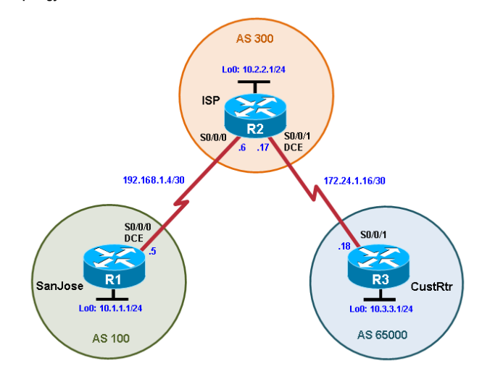

**Objectives:**

• Use BGP commands to prevent private AS numbers from being advertised to the outside world.

• Use the AS_PATH attribute to filter BGP routes based on their source AS numbers.

**Step 1: Prepare the routers for the lab.**

**Cable the network as shown in the topology diagram. Erase the startup configuration and reload each routerto clear previous configurations.**

**Step 2: Configure the hostname and interface addresses.**

1. **Copy and paste the following configurations into your routers to begin.Router R1**

**Router R1 (hostname SanJose)**

hostname SanJose

!

interface Loopback0

ip address 10.1.1.1 255.255.255.0

!

interface Serial0/0/0

ip address 192.168.1.5 255.255.255.252

clock rate 128000

no shutdown

**Router R2 (hostname ISP)**

hostname ISP

!

interface Loopback0

ip address 10.2.2.1 255.255.255.0

!

interface Serial0/0/0

ip address 192.168.1.6 255.255.255.252

no shutdown

!

interface Serial0/0/1

ip address 172.24.1.17 255.255.255.252

clock rate 128000

no shutdown

**Router R3 (hostname CustRtr)**

hostname CustRtr

!

interface Loopback0

ip address 10.3.3.1 255.255.255.0

!

interface Serial0/0/1

ip address 172.24.1.18 255.255.255.252

no shutdown

**Step 3: Configure BGP.**

1. **Configure BGP for normal operation. Enter the appropriate BGP commands on each router so that they**

SanJose(config)# **router bgp 100**

SanJose(config-router)# **neighbor 192.168.1.6 remote-as 300**

SanJose(config-router)# **network 10.1.1.0 mask 255.255.255.0**

ISP(config)# **router bgp 300**

ISP(config-router)# **neighbor 192.168.1.5 remote-as 100**

ISP(config-router)# **neighbor 172.24.1.18 remote-as 65000**

ISP(config-router)# **network 10.2.2.0 mask 255.255.255.0**

CustRtr(config)# **router bgp 65000**

CustRtr(config-router)# **neighbor 172.24.1.17 remote-as 300**

CustRtr(config-router)# **network 10.3.3.0 mask 255.255.255.0**

1. **Verify that these routers have established the appropriate neighbor relationships by issuing the show ip bgp neighbors command on each router.**

## ISP# show ip bgp neighbors

BGP neighbor is 172.24.1.18, remote AS 65000, external link

BGP version 4, remote router ID 10.3.3.1

BGP state = Established, up for 00:02:05

<output omitted>

BGP neighbor is 192.168.1.5, remote AS 100, external link

BGP version 4, remote router ID 10.1.1.1

BGP state = Established, up for 00:04:19

<output omitted>

**Step 4: Remove the private AS.**

1. **Display the SanJose routing table using the show ip route command. SanJose should have a route to both 10.2.2.0 and 10.3.3.0. Troubleshoot if necessary.**

SanJose# **show ip route**

Codes: C - connected, S - static, R - RIP, M - mobile, B - BGP

D - EIGRP, EX - EIGRP external, O - OSPF, IA - OSPF inter area N1 - OSPF NSSA external type 1, N2 - OSPF NSSA external type 2 E1 - OSPF external type 1, E2 - OSPF external type 2

i - IS-IS, su - IS-IS summary, L1 - IS-IS level-1, L2 - IS-IS level-2 ia - IS-IS inter area, * - candidate default, U - per-user static

route

o - ODR, P - periodic downloaded static route

Gateway of last resort is not set

10.0.0.0/24 is subnetted, 3 subnets

B 10.3.3.0 [20/0] via 192.168.1.6, 00:01:11

B 10.2.2.0 [20/0] via 192.168.1.6, 00:02:16

C 10.1.1.0 is directly connected,

Loopback0 192.168.1.0/30 is subnetted, 1 subnets

C 192.168.1.4 is directly connected, Serial0/0/0

1. **Ping the 10.3.3.1 address from SanJose.**

**Why does this fail?**

1. **Ping again, this time as an extended ping, sourcing from the Loopback0 interface address.**

SanJose# **ping**

Protocol [ip]:

Target IP address: 10.3.3.1

Repeat count [5]:

Datagram size [100]:

Timeout in seconds [2]:

Extended commands [n]: y

Source address or interface: 10.1.1.1

Type of service [0]:

Set DF bit in IP header? [no]:

Validate reply data? [no]:

Data pattern [0xABCD]:

Loose, Strict, Record, Timestamp, Verbose[none]:

Sweep range of sizes [n]:

Type escape sequence to abort.

Sending 5, 100-byte ICMP Echos to 10.3.3.1, timeout is 2 seconds:

Packet sent with a source address of 10.1.1.1

!!!!!

Success rate is 100 percent (5/5), round-trip min/avg/max = 16/65/96 ms

SanJose#

SanJose# **ping 10.3.3.1 source 10.1.1.1**

**Type escape sequence to abort.**

**Sending 5, 100-byte ICMP Echos to 10.3.3.1, timeout is 2 seconds:**

**Packet sent with a source address of 10.1.1.1**

**!!!!!**

**Success rate is 100 percent (5/5), round-trip min/avg/max = 24/45/52 ms**

**SanJose#**

1. **Check the BGP table from SanJose by using the show ip bgp command. Note the AS path for the 10.3.3.0 network. The AS 65000 should be listed in the path to 10.3.3.0.**

SanJose# **show ip bgp**

**BGP table version is 4, local router ID is 10.1.1.1**

**Status codes: s suppressed, d damped, h history, * valid, > best, i - internal,**

**r RIB-failure, S Stale, m multipath, b backup-path, f RT-Filter,**

**x best-external, a additional-path, c RIB-compressed,**

**Origin codes: i - IGP, e - EGP, ? - incomplete**

**RPKI validation codes: V valid, I invalid, N Not found**

**Network Next Hop Metric LocPrf Weight Path**

**\*> 10.1.1.0/24 0.0.0.0 0 32768 i**

**\*> 10.2.2.0/24 192.168.1.6 0 0 300 i**

**\*> 10.3.3.0/24 192.168.1.6 0 300 65000 i**

SanJose#

1. **Configure ISP to strip the private AS numbers from BGP routes exchanged with SanJose using the following commands.**

ISP(config)# **router bgp 300**

ISP(config-router)# **neighbor 192.168.1.5 remove-private-as**

1. **After issuing these commands, use the clear ip bgp * command on ISP to reestablish the BGP relationship between the three routers. Wait several seconds and then return to SanJose to check its routing table.**

SanJose should be able to ping 10.3.3.1 using its loopback 0 interface as the source of the ping.

SanJose# **ping 10.3.3.1 source lo0**

Type escape sequence to abort.

Sending 5, 100-byte ICMP Echos to 10.3.3.1, timeout is 2 seconds: Packet sent with a source address of 10.1.1.1

!!!!!

Success rate is 100 percent (5/5), round-trip min/avg/max = 28/28/32 ms

1. **Now check the BGP table on SanJose. The AS_ PATH to the 10.3.3.0 network should be AS 300. It no longer has the private AS in the path.**

SanJose# **show ip bgp**

BGP table version is 5, local router ID is 10.1.1.1

Status codes: s suppressed, d damped, h history, * valid, > best, i - internal,

r RIB-failure, S Stale, m multipath, b backup-path, f RT-Filter,

x best-external, a additional-path, c RIB-compressed,

Origin codes: i - IGP, e - EGP, ? - incomplete

RPKI validation codes: V valid, I invalid, N Not found

Network Next Hop Metric LocPrf Weight Path

*> 10.1.1.0/24 0.0.0.0 0 32768 i

*> 10.2.2.0/24 192.168.1.6 0 0 300 i

*> 10.3.3.0/24 192.168.1.6 0 300 i

SanJose#

**Step 5: Use the AS_PATH attribute to filter routes.**

1. **Configure a special kind of access list to match BGP routes with an AS_PATH attribute that both begins and ends with the number 100. Enter the following commands on ISP.**

ISP(config)# **ip as-path access-list 1 deny ^100$**

ISP(config)# **ip as-path access-list 1 permit .\***

1. **Apply the configured access list using the neighbor command with the filter-list option.**

ISP(config)# **router bgp 300**

ISP(config-router)# **neighbor 172.24.1.18 filter-list 1 out**

1. **Use the clear ip bgp * command to reset the routing information. Wait several seconds and then check the routing table for ISP. The route to 10.1.1.0 should be in the routing table.**

ISP# **show ip route**

<output omitted>

172.24.0.0/30 is subnetted, 1 subnets

C 172.24.1.16 is directly connected, Serial0/0/1 10.0.0.0/24 is subnetted, 3 subnets

B 10.3.3.0 [20/0] via 172.24.1.18, 00:07:34

C 10.2.2.0 is directly connected, Loopback0

192.168.1.0/30 is subnetted, 1 subnets

C 192.168.1.4 is directly connected, Serial0/0/0

1. **Check the routing table for CustRtr. It should not have a route to 10.1.1.0 in its routing table.**

CustRtr# **show ip route**

<output omitted>

172.24.0.0/30 is subnetted, 1 subnets

C 172.24.1.16 is directly connected, Serial0/0/1 10.0.0.0/24 is subnetted, 2 subnets

C 10.3.3.0 is directly connected, Loopback0

B 10.2.2.0 [20/0] via 172.24.1.17, 00:11:57

1. **Return to ISP and verify that the filter is working as intended. Issue the show ip bgp regexp ^100$ command.**

## I ISP# show ip bgp regexp ^100$

BGP table version is 4, local router ID is 10.2.2.1

Status codes: s suppressed, d damped, h history, * valid, > best, i – internal Origin codes: i - IGP, e - EGP, ? - incomplete

Network Next Hop Metric LocPrf Weight Path

*> 10.1.1.0 192.168.1.5 0 0 100 i

1. **Run the following Tcl script on all routers to verify whether there is connectivity. All pings from ISP should be successful. SanJose should not be able to ping the CustRtr loopback 10.3.3.1 or the WAN link**

iISP# **tclsh**

**foreach address { 10.1.1.1**

**10.2.2.1**

**10.3.3.1**

**192.168.1.5**

**192.168.1.6**

**172.24.1.17**

**172.24.1.18**

**} {**

**ping $address }**

**Router Interface Summary Table:**

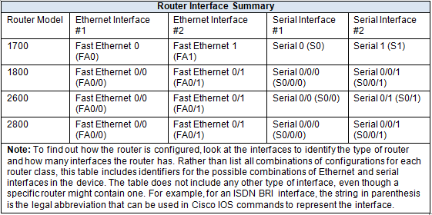

**Practical No.: 04**

**Configuring IBGP and EBGP Sessions, Local Preference, and MED**

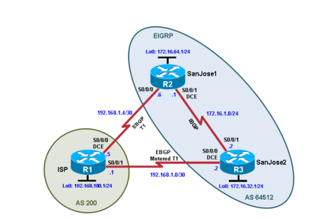**Topology:**

**Objectives:**

• For IBGP peers to correctly exchange routing information, use the next-hop-self command with the Local-Preference and MED attributes

• Ensure that the flat-rate, unlimited-use T1 link is used for sending and receiving data to and from the AS 200 on ISP and that the metered T1 only be used in the event that the primary T1 link has failed.

**Step 0: Suggested starting configurations.**

1. **Apply the following configuration to each router along with the appropriate hostname. The exec-timeout 0 0 command should only be used in a lab environment.**

Router(config)# no ip domain-lookup

Router(config)# line con 0

Router(config-line)# logging synchronous

Router(config-line)# exec-timeout 0 0

**Step 1: Configure interface addresses.**

1. **Using the addressing scheme in the diagram, create the loopback interfaces and apply IPv4 addresses to these and the serial interfaces on ISP (R1), SanJose1 (R2), and SanJose2 (R3).**

**Router R1 (hostname ISP):-**

ISP(config)# interface Loopback0

ISP(config-if)# ip address 192.168.100.1 255.255.255.0 ISP(config-if)# exit

ISP(config)# interface Serial4/0

ISP(config-if)# ip address 192.168.1.5 255.255.255.252 ISP(config-if)# clock rate 128000

ISP(config-if)# no shutdown ISP(config-if)# exit ISP(config)# interface Serial4/2

ISP(config-if)# ip address 192.168.1.1 255.255.255.252 ISP(config-if)# no shutdown

ISP(config-if)# end ISP#

**Router R2 (hostname SanJose1)**

SanJose1(config)# interface Loopback0

SanJose1(config-if)# ip address 172.16.64.1 255.255.255.0 SanJose1(config-if)# exit

SanJose1(config)# interface Serial0/0/0

SanJose1(config-if)# ip address 192.168.1.6 255.255.255.252 SanJose1(config-if)# no shutdown

SanJose1(config-if)# exit SanJose1(config)# interface Serial0/0/1

SanJose1(config-if)# ip address 172.16.1.1 255.255.255.0 SanJose1(config-if)# clock rate 128000

SanJose1(config-if)# no shutdown SanJose1(config-if)# end SanJose1#

**Router R3 (hostname SanJose2)**

SanJose2(config)# interface Loopback0

SanJose2(config-if)# ip address 172.16.32.1 255.255.255.0 SanJose2(config-if)# exit

SanJose2(config)# interface Serial0/0/0

SanJose2(config-if)# ip address 192.168.1.2 255.255.255.252 SanJose2(config-if)# clock rate 128000

SanJose2(config-if)# no shutdown SanJose2(config-if)# exit SanJose2(config)# interface Serial0/0/1

SanJose2(config-if)# ip address 172.16.1.2 255.255.255.0 SanJose2(config-if)# no shutdown

SanJose2(config-if)# end SanJose2#

**Step 2: Configure EIGRP.**

Configure EIGRP between the SanJose1 and SanJose2 routers. (Note: If using an IOS prior to 15.0, use the no auto-summary router configuration command to disable automatic summarization. This command is the default beginning with IOS 15.)

SanJose1(config)# router eigrp 1

SanJose1(config-router)# network 172.16.0.0

SanJose2(config)# router eigrp 1

SanJose2(config-router)# network 172.16.0.0

**Step 3: Configure IBGP and verify BGP neighbors.**

1. **Configure IBGP between the SanJose1 and SanJose2 routers. On the SanJose1 router, enter the following configuration.**

SanJose1(config)# router bgp 64512

SanJose1(config-router)# neighbor 172.16.32.1 remote-as 64512 SanJose1(config-router)# neighbor 172.16.32.1 update-source lo0

1. **Complete the IBGP configuration on SanJose2 using the following commands. SanJose2(config)# router bgp 64512**

SanJose2(config-router)# neighbor 172.16.64.1 remote-as 64512 SanJose2(config-router)# neighbor 172.16.64.1 update-source lo0

1. **Verify that SanJose1 and SanJose2 become BGP neighbors by issuing the show ip bgp neighbors command on SanJose1. View the following partial output. If the BGP state is not established, troubleshoot the connection.**

SanJose2# show ip bgp neighbors

BGP neighbor is 172.16.64.1, remote AS 64512, internal link BGP version 4, remote router ID 172.16.64.1

BGP state = Established, up for 00:00:22

Last read 00:00:22, last write 00:00:22, hold time is 180, keepalive interval is 60 seconds

<output omitted>

**Step 4: Configure EBGP and verify BGP neighbors.**

1. **Configure ISP to run EBGP with SanJose1 and SanJose2. Enter the following commands on ISP. ISP(config)# router bgp 200**

ISP(config-router)# neighbor 192.168.1.6 remote-as 64512

ISP(config-router)# neighbor 192.168.1.2 remote-as 64512

ISP(config-router)# network 192.168.100.0

1. **Configure a discard static route for the 172.16.0.0/16 network. Any packets that do not have a more specific match (longer match) for a 172.16.0.0 subnet will be dropped instead of sent to the ISP. Later in this lab we will configure a default route to the ISP.**

SanJose1(config)# ip route 172.16.0.0 255.255.0.0 null0

1. **Configure SanJose1 as an EBGP peer to ISP.**

SanJose1(config)# router bgp 64512

SanJose1(config-router)# neighbor 192.168.1.5 remote-as 200

SanJose1(config-router)# network 172.16.0.0

1. **Use the show ip bgp neighbors command to verify that SanJose1 and ISP have reached the established state. Troubleshoot if necessary.**

SanJose1# show ip bgp neighbors

BGP neighbor is 172.16.32.1, remote AS 64512, internal link BGP version 4, remote router ID 172.16.32.1

BGP state = Established, up for 00:12:43

<output omitted>

BGP neighbor is 192.168.1.5, remote AS 200, external link BGP version 4, remote router ID 192.168.100.1

BGP state = Established, up for 00:06:49

Last read 00:00:42, last write 00:00:45, hold time is 180, keepalive interval is 60 seconds

<output omitted>

1. **Configure a discard static route for 172.16.0.0/16 on SanJose2 and as an EBGP peer to ISP.**

SanJose2(config)# ip route 172.16.0.0 255.255.0.0 null0

SanJose2(config)# router bgp 64512

SanJose2(config-router)# neighbor 192.168.1.1 remote-as 200

SanJose2(config-router)# network 172.16.0.0

**Step 5: View BGP summary output.**

In Step 4, the **show ip bgp neighbors** command was used to verify that SanJose1 and ISP had reached the established state. A useful alternative command is **show ip bgp summary**. The output should be similar to the following.

SanJose2# show ip bgp summary

BGP router identifier 172.16.32.1, local AS number 64512 BGP table version is 6, main routing table version 6

2 network entries using 288 bytes of memory 4 path entries using 320 bytes of memory

4/2 BGP path/bestpath attribute entries using 640 bytes of memory 1 BGP AS-PATH entries using 24 bytes of memory

0 BGP route-map cache entries using 0 bytes of memory 0 BGP filter-list cache entries using 0 bytes of memory BGP using 1272 total bytes of memory

BGP activity 2/0 prefixes, 4/0 paths, scan interval 60 secs

NeighborV AS MsgRcvd MsgSent TblVer InQ OutQ Up/Down State/PfxRcd

|  |  |  |  |  |  |  |  |  |
| --- | --- | --- | --- | --- | --- | --- | --- | --- |
| 172.16.64.1 | 4 | 64512 | 27 | 26 | 6 | 0 | 0 00:18:15 | 2 |
| 192.168.1.1 | 4 | 200 | 10 | 7 | 6 | 0 | 0 00:01:42 | 1 |
| SanJose2# |  |  |  |  |  |  |  |  |

**Step 6: Verify which path the traffic takes.**

1. **Clear the IP BGP conversation with the clear ip bgp * command on ISP. Wait for the conversations to reestablish with each SanJose router.**

ISP# clear ip bgp *

ISP#

*Mar 23 22:05:32.427: %BGP-5-ADJCHANGE: neighbor 192.168.1.2 Down User reset

*Mar 23 22:05:32.427: %BGP_SESSION-5-ADJCHANGE: neighbor 192.168.1.2 IPv4 Unicast

topology base removed from session User reset

*Mar 23 22:05:32.427: %BGP-5-ADJCHANGE: neighbor 192.168.1.6 Down User reset

*Mar 23 22:05:32.427: %BGP_SESSION-5-ADJCHANGE: neighbor 192.168.1.6 IPv4 Unicast

topology base removed from session User reset

*Mar 23 22:05:32.851: %BGP-5-ADJCHANGE: neighbor 192.168.1.2 Up

*Mar 23 22:05:32.851: %BGP-

ISP#5-ADJCHANGE: neighbor 192.168.1.6 Up

ISP#

1. **Test whether ISP can ping the loopback 0 address of 172.16.64.1 on SanJose1 and the serial link between SanJose1 and SanJose2, 172.16.1.1.**

ISP# ping 172.16.64.1

Type escape sequence to abort.

Sending 5, 100-byte ICMP Echos to 172.16.64.1, timeout is 2 seconds:

.....

Success rate is 0 percent (0/5) ISP#

ISP# ping 172.16.1.1

Type escape sequence to abort.

Sending 5, 100-byte ICMP Echos to 172.16.1.1, timeout is 2 seconds:

.....

Success rate is 0 percent (0/5) ISP#

1. **Now ping from ISP to the loopback 0 address of 172.16.32.1 on SanJose2 and the serial link between SanJose1 and SanJose2, 172.16.1.2.**

ISP# ping 172.16.32.1

Type escape sequence to abort.

Sending 5, 100-byte ICMP Echos to 172.16.32.1, timeout is 2 seconds:

!!!!!

Success rate is 100 percent (5/5), round-trip min/avg/max = 12/14/16 ms ISP# ping 172.16.1.2

Type escape sequence to abort.

Sending 5, 100-byte ICMP Echos to 172.16.1.2, timeout is 2 seconds:

!!!!!

Success rate is 100 percent (5/5), round-trip min/avg/max = 12/13/16 ms ISP#

1. **Issue the show ip bgp command on ISP to verify BGP routes and metrics.**

ISP**# show ip bgp**

BGP table version is 3, local router ID is 192.168.100.1

Status codes: s suppressed, d damped, h history, * valid, > best, i - internal, r RIB-failure, S Stale, m multipath, b backup-path, f RT-Filter,

x best-external, a additional-path, c RIB-compressed, Origin codes: i - IGP, e - EGP, ? - incomplete

RPKI validation codes: V valid, I invalid, N Not found Network Next Hop Metric LocPrf Weight Path

|  |  |  |  |
| --- | --- | --- | --- |
| * 172.16.0.0 | 192.168.1.6 | 0 | 0 64512 i |
| *> | 192.168.1.2 | 0 | 0 64512 i |
| *> 192.168.100.0 0.0.0.0  ISP#  ISP# **show ip bgp** | | 0 | 32768 i |

1. **At this point, the ISP router should be able to get to each network connected to SanJose1 and SanJose2 from the loopback address 192.168.100.1. Use the extended ping command and specify the source address of ISP Lo0 totest.**

ISP# **ping 172.16.1.1 source 192.168.100.1**

Type escape sequence to abort.

Sending 5, 100-byte ICMP Echos to 172.16.1.1, timeout is 2 seconds:

Packet sent with a source address of 192.168.100.1

!!!!!

Success rate is 100 percent (5/5), round-trip min/avg/max = 20/21/24 ms ISP# **ping 172.16.32.1 source 192.168.100.1**

Type escape sequence to abort.

Sending 5, 100-byte ICMP Echos to 172.16.32.1, timeout is 2 seconds: Packet sent with a source address of 192.168.100.1

!!!!!

Success rate is 100 percent (5/5), round-trip min/avg/max = 12/15/16 ms ISP# **ping 172.16.1.2 source 192.168.100.1**

Type escape sequence to abort.

Sending 5, 100-byte ICMP Echos to 172.16.1.2, timeout is 2 seconds:

Packet sent with a source address of 192.168.100.1

!!!!!

Success rate is 100 percent (5/5), round-trip min/avg/max = 12/15/16 ms ISP#

ISP# **ping 172.16.64.1 source 192.168.100.1**

Type escape sequence to abort.

Sending 5, 100-byte ICMP Echos to 172.16.64.1, timeout is 2 seconds: Packet sent with a source address of 192.168.100.1

!!!!!

Success rate is 100 percent (5/5), round-trip min/avg/max = 20/21/24 ms

You can also use the extended ping dialogue to specify the source address, as shown in this example. ISP# **ping**

Protocol [ip]:

Target IP address: **172.16.64.1**

Repeat count [5]:

Datagram size [100]:

Timeout in seconds [2]:

Extended commands [n]: **y**

Source address or interface: **192.168.100.1**

Type of service [0]:

Set DF bit in IP header? [no]:

Validate reply data? [no]:

Data pattern [0xABCD]:

Loose, Strict, Record, Timestamp, Verbose[none]:

Sweep range of sizes [n]:

Type escape sequence to abort.

Sending 5, 100-byte ICMP Echos to 172.16.64.1, timeout is 2 seconds: Packet sent with a source address of 192.168.100.1

!!!!!

Success rate is 100 percent (5/5), round-trip min/avg/max = 20/20/24 ms ISP#

**Step 7: Configure the BGP next-hop-self feature.**

SanJose1 is unaware of the link between ISP and SanJose2, and SanJose2 is unaware of the link between ISP and SanJose1.

1. **Issue the following commands on the ISP router.**

ISP(config)# **router bgp 200**

ISP(config-router)# **network 192.168.1.0 mask 255.255.255.252**

ISP(config-router)# **network 192.168.1.4 mask 255.255.255.252**

1. **Issue the show ip bgp command to verify that the ISP is correctly injecting its own WAN links into** **BGP**.

ISP# **show ip bgp**

BGP table version is 5, local router ID is 192.168.100.1

Status codes: s suppressed, d damped, h history, * valid, > best, i - internal, r RIB-failure, S Stale, m multipath, b backup-path, f RT-Filter,

x best-external, a additional-path, c RIB-compressed, Origin codes: i - IGP, e - EGP, ? – incomplete

RPKI validation codes: V valid, I invalid, N Not found Network Next Hop Metric LocPrf Weight Path

|  |  |  |  |  |  |
| --- | --- | --- | --- | --- | --- |
| * 172.16.0.0 | 192.168.1.6 |  | 0 | 0 64512 i | |
| *> | 192.168.1.2 | 0 |  | 0 64512 i | |
| *> 192.168.1.0/30 0.0.0.0 | | 0 | | 32768 i | |
| *> 192.168.1.4/30 0.0.0.0 | | 0 | | 32768 i | |
| *> 192.168.100.0 0.0.0.0 | | 0 | | 32768 i |  |
| ISP# | |  | |  |  |

1. **Verify on SanJose1 and SanJose2 that the opposite WAN link is included in the routing table. The output from SanJose2 is as follows.**

SanJose2# **show ip route**

Codes: L - local, C - connected, S - static, R - RIP, M - mobile, B - BGP D - EIGRP, EX - EIGRP external, O - OSPF, IA - OSPF inter area N1 - OSPF NSSA external type 1, N2 - OSPF NSSA external type 2 E1 - OSPF external type 1, E2 - OSPF external type 2

i - IS-IS, su - IS-IS summary, L1 - IS-IS level-1, L2 - IS-IS level-2 ia - IS-IS inter area, * - candidate default, U - per-user static route o - ODR, P - periodic downloaded static route, H - NHRP, l - LISP a - application route

+ - replicated route, % - next hop override Gateway of last resort is not set

172.16.0.0/16 is variably subnetted, 6 subnets, 3 masks S 172.16.0.0/16 is directly connected, Null0

C 172.16.1.0/24 is directly connected, Serial0/0/1 L 172.16.1.2/32 is directly connected, Serial0/0/1 C 172.16.32.0/24 is directly connected, Loopback0 L 172.16.32.1/32 is directly connected, Loopback0

D 172.16.64.0/24 [90/2297856] via 172.16.1.1, 00:52:03, Serial0/0/1

192.168.1.0/24 is variably subnetted, 3 subnets, 2 masks C 192.168.1.0/30 is directly connected, Serial0/0/0

L 192.168.1.2/32 is directly connected, Serial0/0/0 B 192.168.1.4/30 [20/0] via 192.168.1.1, 00:01:03 B 192.168.100.0/24 [20/0] via 192.168.1.1, 00:25:20

SanJose2

1. **To better understand the next-hop-self command we will remove ISP advertising its two WAN links and shutdown the WAN link between ISP and SanJose2.**

ISP(config)# **router bgp 200**

ISP(config-router)# **no network 192.168.1.0 mask 255.255.255.252**

ISP(config-router)# **no network 192.168.1.4 mask 255.255.255.252**

ISP(config-router)# **exit** ISP(config)# **interface serial 0/0/1** ISP(config-if)# **shutdown** ISP(config-if)#

1. **Display SanJose2’s BGP table using the show ip bgp command and the IPv4 routing table with show ip route.**

SanJose2# **show ip bgp**

BGP table version is 1, local router ID is 172.16.32.1

Status codes: s suppressed, d damped, h history, * valid, > best, i - internal, r RIB-failure, S Stale, m multipath, b backup-path, f RT-Filter, x best-external, a additional-path, c RIB-compressed,

Origin codes: i - IGP, e - EGP, ? - incomplete

RPKI validation codes: V valid, I invalid, N Not found

Network Next Hop Metric LocPrf Weight Path

* i 172.16.0.0 172.16.64.1 0 100 0 i

* i 192.168.100.0 192.168.1.5 0 100 0 200 i

SanJose2#

SanJose2# **show ip route**

Codes: L - local, C - connected, S - static, R - RIP, M - mobile, B - BGP D - EIGRP, EX - EIGRP external, O - OSPF, IA - OSPF inter area N1 - OSPF NSSA external type 1, N2 - OSPF NSSA external type 2 E1 - OSPF external type 1, E2 - OSPF external type 2

i - IS-IS, su - IS-IS summary, L1 - IS-IS level-1, L2 - IS-IS level-2 ia - IS-IS inter area, * - candidate default, U - per-user static route o - ODR, P - periodic downloaded static route, H - NHRP, l - LISP a - application route

+ - replicated route, % - next hop override Gateway of last resort is not set

172.16.0.0/16 is variably subnetted, 6 subnets, 3 masks S 172.16.0.0/16 is directly connected, Null0

C 172.16.1.0/24 is directly connected, Serial0/0/1 L 172.16.1.2/32 is directly connected, Serial0/0/1 C 172.16.32.0/24 is directly connected, Loopback0 L 172.16.32.1/32 is directly connected, Loopback0

D 172.16.64.0/24 [90/2297856] via 172.16.1.1, 02:41:46, Serial0/0/1

SanJose2#

1. **Issue the next-hop-self command on SanJose1 and SanJose2 to advertise themselves as the next hop to their IBGP peer.**

SanJose1(config)# **router bgp 64512**

SanJose1(config-router)# **neighbor 172.16.32.1 next-hop-self**

SanJose2(config)# **router bgp 64512**

SanJose2(config-router)# **neighbor 172.16.64.1 next-hop-self**

1. **Reset BGP operation on either router with the clear ip bgp * command.**

SanJose1# **clear ip bgp \***

SanJose1#

SanJose2# **clear ip bgp \***

SanJose2#

1. **After the routers have returned to established BGP speakers, issue the show ip bgp command on SanJose2 and notice that the next hop is now SanJose1 instead of ISP.**

SanJose2# **show ip bgp**

BGP table version is 5, local router ID is 172.16.32.1

Status codes: s suppressed, d damped, h history, * valid, > best, i - internal, r RIB-failure, S Stale, m multipath, b backup-path, f RT-Filter,

x best-external, a additional-path, c RIB-compressed, Origin codes: i - IGP, e - EGP, ? - incomplete

RPKI validation codes: V valid, I invalid, N Not found

Network Next Hop Metric LocPrf Weight Path

*> 172.16.0.0 0.0.0.0 0 32768 i

* i 172.16.64.1 0 100 0 i

*>i 192.168.100.0 172.16.64.1 0 100 0 200 i

SanJose2#

1. **The show ip route command on SanJose2 now displays the 192.168.100.0/24 network because SanJose1 is the next hop, 172.16.64.1, which is reachable from SanJose2.**

SanJose2# **show ip route**

Codes: L - local, C - connected, S - static, R - RIP, M - mobile, B - BGP D - EIGRP, EX - EIGRP external, O - OSPF, IA - OSPF inter area N1 - OSPF NSSA external type 1, N2 - OSPF NSSA external type 2 E1 - OSPF external type 1, E2 - OSPF external type 2

i - IS-IS, su - IS-IS summary, L1 - IS-IS level-1, L2 - IS-IS level-2 ia - IS-IS inter area, * - candidate default, U - per-user static route o - ODR, P - periodic downloaded static route, H - NHRP, l - LISP a - application route

+ - replicated route, % - next hop override Gateway of last resort is not set

172.16.0.0/16 is variably subnetted, 6 subnets, 3 masks S 172.16.0.0/16 is directly connected, Null0

C 172.16.1.0/24 is directly connected, Serial0/0/1 L 172.16.1.2/32 is directly connected, Serial0/0/1 C 172.16.32.0/24 is directly connected, Loopback0 L 172.16.32.1/32 is directly connected, Loopback0

D 172.16.64.0/24 [90/2297856] via 172.16.1.1, 04:27:19, Serial0/0/1 B 192.168.100.0/24 [200/0] via 172.16.64.1, 00:00:46

SanJose2#

1. **Before configuring the next BGP attribute, restore the WAN link between ISP and SanJose3. ISP(config)# interface serial 0/0/1**

ISP(config-if)# **no shutdown**

ISP(config-if)#

SanJose2# **show ip route**

Codes: L - local, C - connected, S - static, R - RIP, M - mobile, B - BGP D - EIGRP, EX - EIGRP external, O - OSPF, IA - OSPF inter area N1 - OSPF NSSA external type 1, N2 - OSPF NSSA external type 2 E1 - OSPF external type 1, E2 - OSPF external type 2

i - IS-IS, su - IS-IS summary, L1 - IS-IS level-1, L2 - IS-IS level-2 ia - IS-IS inter area, * - candidate default, U - per-user static route o - ODR, P - periodic downloaded static route, H - NHRP, l - LISP a - application route

+ - replicated route, % - next hop override Gateway of last resort is not set

172.16.0.0/16 is variably subnetted, 6 subnets, 3 masks S 172.16.0.0/16 is directly connected, Null0

C 172.16.1.0/24 is directly connected, Serial0/0/1 L 172.16.1.2/32 is directly connected, Serial0/0/1 C 172.16.32.0/24 is directly connected, Loopback0 L 172.16.32.1/32 is directly connected, Loopback0

D 172.16.64.0/24 [90/2297856] via 172.16.1.1, 04:37:34, Serial0/0/1

192.168.1.0/24 is variably subnetted, 2 subnets, 2 masks C 192.168.1.0/30 is directly connected, Serial0/0/0

L 192.168.1.2/32 is directly connected, Serial0/0/0 B 192.168.100.0/24 [20/0] via 192.168.1.1, 00:01:35

SanJose2#

**Step 8: Set BGP local preference.**

At this point, everything looks good, with the exception of default routes, the outbound flow of data, and inbound packet flow.

1. Because the local preference value is shared between IBGP neighbors, configure a simple route map that references the local preference value on SanJose1 and SanJose2. This policy adjusts outbound traffic to prefer the link off the SanJose1 router instead of the metered T1 off SanJose2.

SanJose1(config)# **route-map PRIMARY_T1_IN permit 10** SanJose1(config-route-map)# **set local-preference 150** SanJose1(config-route-map)# **exit**

SanJose1(config)# **router bgp 64512**

SanJose1(config-router)# **neighbor 192.168.1.5 route-map PRIMARY_T1_IN in**

SanJose2(config)# **route-map SECONDARY_T1_IN permit 10** SanJose2(config-route-map)# **set local-preference 125** SanJose1(config-route-map)# **exit**

SanJose2(config)# **router bgp 64512**

SanJose2(config-router)# **neighbor 192.168.1.1 route-map SECONDARY_T1_IN in**

1. Use the **clear ip bgp * soft** command after configuring this new policy. When the conversations have been reestablished, issue the **show ip bgp** command on SanJose1 and SanJose2.

SanJose1# **clear ip bgp * soft**

SanJose2# **clear ip bgp * soft**

SanJose1# **show ip bgp**

BGP table version is 3, local router ID is 172.16.64.1

Status codes: s suppressed, d damped, h history, * valid, > best, i - internal,

r RIB-failure, S Stale, m multipath, b backup-path, f RT-Filter, x best-external, a additional-path, c RIB-compressed,

Origin codes: i - IGP, e - EGP, ? - incomplete

RPKI validation codes: V valid, I invalid, N Not found

Network Next Hop Metric LocPrf Weight Path

|  |  |  |  |  |
| --- | --- | --- | --- | --- |
| * i 172.16.0.0 | 172.16.32.1 | 0 | 100 | 0 i |
| *> | 0.0.0.0 | 0 |  | 32768 i |
| *> 192.168.100.0 | 192.168.1.5 | 0 | 150 | 0 200 i |

SanJose1#

SanJose2# **show ip bgp**

BGP table version is 7, local router ID is 172.16.32.1

Status codes: s suppressed, d damped, h history, * valid, > best, i - internal,

r RIB-failure, S Stale, m multipath, b backup-path, f RT-Filter, x best-external, a additional-path, c RIB-compressed,

Origin codes: i - IGP, e - EGP, ? - incomplete

RPKI validation codes: V valid, I invalid, N Not found

Network Next Hop Metric LocPrf Weight Path

|  |  |  |  |  |
| --- | --- | --- | --- | --- |
| * i 172.16.0.0 | 172.16.64.1 | 0 | 100 | 0 i |
| *> | 0.0.0.0 | 0 |  | 32768 i |
| *>i 192.168.100.0 | 172.16.64.1 | 0 | 150 | 0 200 i |
| * | 192.168.1.1 | 0 | 125 | 0 200 i |

SanJose2#

**Step 9: Set BGP MED.**

1. In the previous step we saw that SanJose1 and SanJose2 will route traffic for 192.168.100.0/24 using the link between SanJose1 and ISP.

ISP# **show ip bgp**

BGP table version is 22, local router ID is 192.168.100.1

Status codes: s suppressed, d damped, h history, * valid, > best, i - internal,

r RIB-failure, S Stale, m multipath, b backup-path, f RT-Filter, x best-external, a additional-path, c RIB-compressed,

Origin codes: i - IGP, e - EGP, ? - incomplete

RPKI validation codes: V valid, I invalid, N Not found

|  |  |  |  |  |  |  |
| --- | --- | --- | --- | --- | --- | --- |
|  | Network | Next Hop | Metric | LocPrf | Weight | Path |
| * | 172.16.0.0 | 192.168.1.6 | 0 |  | 0 | 64512 i |
| *> |  | 192.168.1.2 | 0 |  | 0 | 64512 i |
| *> | 192.168.100.0 | 0.0.0.0 | 0 |  | 32768 | i |

ISP# **show ip route**

Codes: L - local, C - connected, S - static, R - RIP, M - mobile, B - BGP D - EIGRP, EX - EIGRP external, O - OSPF, IA - OSPF inter area N1 - OSPF NSSA external type 1, N2 - OSPF NSSA external type 2 E1 - OSPF external type 1, E2 - OSPF external type 2

i - IS-IS, su - IS-IS summary, L1 - IS-IS level-1, L2 - IS-IS level-2 ia - IS-IS inter area, * - candidate default, U - per-user static route o - ODR, P - periodic downloaded static route, H - NHRP, l - LISP a - application route

+ - replicated route, % - next hop override Gateway of last resort is not set

B 172.16.0.0/16 [20/0] via 192.168.1.2, 00:12:45

192.168.1.0/24 is variably subnetted, 4 subnets, 2 masks C 192.168.1.0/30 is directly connected, Serial0/0/1

L 192.168.1.1/32 is directly connected, Serial0/0/1 C 192.168.1.4/30 is directly connected, Serial0/0/0 L 192.168.1.5/32 is directly connected, Serial0/0/0

192.168.100.0/24 is variably subnetted, 2 subnets, 2 masks C 192.168.100.0/24 is directly connected, Loopback0

L 192.168.100.1/32 is directly connected, Loopback0 ISP#

1. Use an extended **ping** command to verify this situation. Specify the **record** option and compare your output to the following. Notice the return path using the exit interface 192.168.1.1 to SanJose2.

SanJose2# **ping**

Protocol [ip]:

Target IP address: **192.168.100.1**

Repeat count [5]:

Datagram size [100]:

Timeout in seconds [2]:

Extended commands [n]: **y**

Source address or interface: **172.16.32.1**

Type of service [0]:

Set DF bit in IP header? [no]:

Validate reply data? [no]:

Data pattern [0xABCD]:

Loose, Strict, Record, Timestamp, Verbose[none]: **record**

Number of hops [ 9 ]:

Loose, Strict, Record, Timestamp, Verbose[RV]:

Sweep range of sizes [n]:

Type escape sequence to abort.

Sending 5, 100-byte ICMP Echos to 192.168.100.1, timeout is 2 seconds: Packet sent with a source address of 172.16.32.1

Packet has IP options: Total option bytes= 39, padded length=40 Record route: <*>

(0.0.0.0)

(0.0.0.0)

(0.0.0.0)

(0.0.0.0)

(0.0.0.0)

(0.0.0.0)

(0.0.0.0)

(0.0.0.0)

(0.0.0.0)

Reply to request 0 (20 ms). Received packet has options Total option bytes= 40, padded length=40 Record route:

(172.16.1.2)

(192.168.1.6)

(192.168.100.1)

(192.168.1.1)

(172.16.32.1) <*>

(0.0.0.0)

(0.0.0.0)

(0.0.0.0)

(0.0.0.0)

End of list

Reply to request 1 (20 ms). Received packet has options Total option bytes= 40, padded length=40

Record route:

(172.16.1.2)

(192.168.1.6)

(192.168.100.1)

(192.168.1.1)

(172.16.32.1) <*>

(0.0.0.0)

(0.0.0.0)

(0.0.0.0)

(0.0.0.0)

End of list

Reply to request 2 (20 ms). Received packet has options Total option bytes= 40, padded length=40

Record route:

(172.16.1.2)

(192.168.1.6)

(192.168.100.1)

(192.168.1.1)

(172.16.32.1) <*>

(0.0.0.0)

(0.0.0.0)

(0.0.0.0)

(0.0.0.0)

End of list

Reply to request 3 (24 ms). Received packet has options Total option bytes= 40, padded length=40

Record route: (172.16.1.2)

(192.168.1.6)

(192.168.100.1)

(192.168.1.1)

(172.16.32.1) <*>

(0.0.0.0)

(0.0.0.0)

(0.0.0.0)

(0.0.0.0)

End of list

Reply to request 4 (20 ms). Received packet has options Total option bytes= 40, padded length=40

Record route:

(172.16.1.2)

(192.168.1.6)

(192.168.100.1)

(192.168.1.1)

(172.16.32.1) <*>

(0.0.0.0)

(0.0.0.0)

(0.0.0.0)

(0.0.0.0)

End of list

1. Create a new policy to force the ISP router to return all traffic via SanJose1. Create a second route map utilizing the MED (metric) that is shared between EBGP neighbors.

SanJose1(config)#**route-map PRIMARY_T1_MED_OUT permit 10**

SanJose1(config-route-map)#**set Metric 50** SanJose1(config-route-map)#**exit** SanJose1(config)#**router bgp 64512**

SanJose1(config-router)#**neighbor 192.168.1.5 route-map PRIMARY_T1_MED_OUT out**

SanJose2(config)#**route-map SECONDARY_T1_MED_OUT permit 10**

SanJose2(config-route-map)#**set Metric 75** SanJose2(config-route-map)#**exit** SanJose2(config)#**router bgp 64512**

SanJose2(config-router)#**neighbor 192.168.1.1 route-map SECONDARY_T1_MED_OUT out**

1. Use the **clear ip bgp * soft** command after issuing this new policy. Issuing the **show ip bgp** command as follows on SanJose1 or SanJose2 does not indicate anything about this newly defined policy.

SanJose1# **clear ip bgp * soft**

SanJose2# **clear ip bgp * soft**

SanJose1# **show ip bgp**

BGP table version is 4, local router ID is 172.16.64.1

Status codes: s suppressed, d damped, h history, * valid, > best, i - internal, r RIB-failure, S Stale, m multipath, b backup-path, f RT-Filter,

x best-external, a additional-path, c RIB-compressed, Origin codes: i - IGP, e - EGP, ? - incomplete

RPKI validation codes: V valid, I invalid, N Not found

Network Next Hop Metric LocPrf Weight Path

* i 172.16.0.0 172.16.32.1 0 100 0 i

*> 0.0.0.0 0 32768 i

*> 192.168.100.0 192.168.1.5 0 150 0 200 i

SanJose1#

1. Reissue an extended **ping** command with the **record** command. Notice the change in return path using the exit interface 192.168.1.5 to SanJose1.

SanJose2# **ping**

Protocol [ip]:

Target IP address: **192.168.100.1**

Repeat count [5]:

Datagram size [100]:

Timeout in seconds [2]:

Extended commands [n]: **y**

Source address or interface: **172.16.32.1**

Type of service [0]:

Set DF bit in IP header? [no]:

Validate reply data? [no]:

Data pattern [0xABCD]:

Loose, Strict, Record, Timestamp, Verbose[none]: record Number of hops [ 9 ]:

Loose, Strict, Record, Timestamp, Verbose[RV]:

Sweep range of sizes [n]:

Type escape sequence to abort.

Sending 5, 100-byte ICMP Echos to 192.168.100.1, timeout is 2 seconds: Packet sent with a source address of 172.16.32.1

Packet has IP options: Total option bytes= 39, padded length=40 Record route: <*>

(0.0.0.0)

(0.0.0.0)

(0.0.0.0)

(0.0.0.0)

(0.0.0.0)

(0.0.0.0)

(0.0.0.0)

(0.0.0.0)

(0.0.0.0)

Reply to request 0 (28 ms). Received packet has options Total option bytes= 40, padded length=40

Record route: (172.16.1.2)

(192.168.1.6)

(192.168.100.1)

(192.168.1.5)

(172.16.1.1)

(172.16.32.1) <*>

(0.0.0.0)

(0.0.0.0)

(0.0.0.0)

End of lis

Reply to request 1 (28 ms). Received packet has options Total option bytes= 40, padded length=40

Record route:

(172.16.1.2)

(192.168.1.6)

(192.168.100.1)

(192.168.1.5)

(172.16.1.1)

(172.16.32.1) <*>

(0.0.0.0)

(0.0.0.0)

(0.0.0.0)

End of list

Reply to request 2 (28 ms). Received packet has options Total option bytes= 40, padded length=40

Record route:

(172.16.1.2)

(192.168.1.6)

(192.168.100.1)

(192.168.1.5)

(172.16.1.1)

(172.16.32.1) <*>

(0.0.0.0)

(0.0.0.0)

(0.0.0.0)

End of list

**Step 10: Establish a default route.**

The final step is to establish a default route that uses a policy statement that adjusts to changes in the network.

1. Configure ISP to inject a default route to both SanJose1 and SanJose2 using BGP using the **default- originate** command. This command does not require the presence of 0.0.0.0 in the ISP router. Configure the 10.0.0.0/8 network which will not be advertised using BGP. This network will be used to test the default route on SanJose1 and SanJose2.

ISP(config)# **router bgp 200**

ISP(config-router)# **neighbor 192.168.1.6 default-originate** ISP(config-router)# **neighbor 192.168.1.2 default-originate** ISP(config-router)# **exit**

ISP(config)# **interface loopback 10**

ISP(config-if)# **ip address 10.0.0.1 255.255.255.0**

ISP(config-if)#

1. Verify that both routers have received the default route by examining the routing tables on SanJose1 and SanJose2. Notice that both routers prefer the route between SanJose1 and ISP.

SanJose1# **show ip route**

Codes: L - local, C - connected, S - static, R - RIP, M - mobile, B - BGP D - EIGRP, EX - EIGRP external, O - OSPF, IA - OSPF inter area N1 - OSPF NSSA external type 1, N2 - OSPF NSSA external type 2 E1 - OSPF external type 1, E2 - OSPF external type 2

i - IS-IS, su - IS-IS summary, L1 - IS-IS level-1, L2 - IS-IS level-2 ia - IS-IS inter area, * - candidate default, U - per-user static route o - ODR, P - periodic downloaded static route, H - NHRP, l - LISP a - application route

+ - replicated route, % - next hop override

Gateway of last resort is 192.168.1.5 to network 0.0.0.0

B* 0.0.0.0/0 [20/0] via 192.168.1.5, 00:00:36

172.16.0.0/16 is variably subnetted, 6 subnets, 3 masks S 172.16.0.0/16 is directly connected, Null0

C 172.16.1.0/24 is directly connected, Serial0/0/1 L 172.16.1.1/32 is directly connected, Serial0/0/1

D 172.16.32.0/24 [90/2297856] via 172.16.1.2, 05:47:24, Serial0/0/1

C 172.16.64.0/24 is directly connected, Loopback0 L 172.16.64.1/32 is directly connected, Loopback0

192.168.1.0/24 is variably subnetted, 2 subnets, 2 masks C 192.168.1.4/30 is directly connected, Serial0/0/0

L 192.168.1.6/32 is directly connected, Serial0/0/0 SanJose1#

SanJose2# **show ip route**

Codes: L - local, C - connected, S - static, R - RIP, M - mobile, B - BGP D - EIGRP, EX - EIGRP external, O - OSPF, IA - OSPF inter area N1 - OSPF NSSA external type 1, N2 - OSPF NSSA external type 2 E1 - OSPF external type 1, E2 - OSPF external type 2

i - IS-IS, su - IS-IS summary, L1 - IS-IS level-1, L2 - IS-IS level-2 ia - IS-IS inter area, * - candidate default, U - per-user static route o - ODR, P - periodic downloaded static route, H - NHRP, l - LISP a - application route

+ - replicated route, % - next hop override Gateway of last resort is 172.16.64.1 to network 0.0.0.0

1. The preferred default route is by way of SanJose1 because of the higher local preference attribute configured on SanJose1 earlier.

SanJose2# **show ip bgp**

BGP table version is 38, local router ID is 172.16.32.1

Status codes: s suppressed, d damped, h history, * valid, > best, i - internal, r RIB-failure, S Stale, m multipath, b backup-path, f RT-Filter,

x best-external, a additional-path, c RIB-compressed, Origin codes: i - IGP, e - EGP, ? - incomplete

RPKI validation codes: V valid, I invalid, N Not found

Network Next Hop Metric LocPrf Weight Path

*>i 0.0.0.0 172.16.64.1 0 150 0 200 i

* 192.168.1.1 125 0 200 i

* i 172.16.0.0 172.16.64.1 0 100 0 i

*> 0.0.0.0 0 32768 i

*>i 192.168.100.0 172.16.64.1 0 150 0 200 i

* 192.168.1.1 0 125 0 200 i

SanJose2#

1. Using the traceroute command verify that packets to 10.0.0.1 is using the default route through SanJose1. SanJose2# **traceroute 10.0.0.1**

Type escape sequence to abort. Tracing the route to 10.0.0.1

VRF info: (vrf in name/id, vrf out name/id) 1 172.16.1.1 8 msec 4 msec 8 msec

2 192.168.1.5 [AS 200] 12 msec * 12 msec

SanJose2#

1. Using the traceroute command verify that packets to 10.0.0.1 is using the default route through SanJose1. SanJose2# **traceroute 10.0.0.1**

Type escape sequence to abort. Tracing the route to 10.0.0.1

VRF info: (vrf in name/id, vrf out name/id) 1 172.16.1.1 8 msec 4 msec 8 msec

2 192.168.1.5 [AS 200] 12 msec * 12 msec

SanJose2#

1. Next, test how BGP adapts to using a different default route when the path between SanJose1 and ISP goes down.

ISP(config)# **interface serial 0/0/0** ISP(config-if)# **shutdown** ISP(config-if)#

1. Verify that both routers are modified their routing tables with the default route using the path between SanJose2 and ISP.

SanJose1# **show ip route**

Codes: L - local, C - connected, S - static, R - RIP, M - mobile, B - BGP D - EIGRP, EX - EIGRP external, O - OSPF, IA - OSPF inter area N1 - OSPF NSSA external type 1, N2 - OSPF NSSA external type 2 E1 - OSPF external type 1, E2 - OSPF external type 2

i - IS-IS, su - IS-IS summary, L1 - IS-IS level-1, L2 - IS-IS level-2 ia - IS-IS inter area, * - candidate default, U - per-user static route o - ODR, P - periodic downloaded static route, H - NHRP, l - LISP a - application route

+ - replicated route, % - next hop override Gateway of last resort is 172.16.32.1 to network 0.0.0.0

B* 0.0.0.0/0 [200/0] via 172.16.32.1, 00:00:06

172.16.0.0/16 is variably subnetted, 6 subnets, 3 masks S 172.16.0.0/16 is directly connected, Null0

C 172.16.1.0/24 is directly connected, Serial0/0/1 L 172.16.1.1/32 is directly connected, Serial0/0/1

D 172.16.32.0/24 [90/2297856] via 172.16.1.2, 05:49:25, Serial0/0/1

C 172.16.64.0/24 is directly connected, Loopback0 L 172.16.64.1/32 is directly connected, Loopback0 B 192.168.100.0/24 [200/0] via 172.16.32.1, 00:00:06

SanJose1#

SanJose2# **show ip route**

Codes: L - local, C - connected, S - static, R - RIP, M - mobile, B - BGP D - EIGRP, EX - EIGRP external, O - OSPF, IA - OSPF inter area N1 - OSPF NSSA external type 1, N2 - OSPF NSSA external type 2 E1 - OSPF external type 1, E2 - OSPF external type 2

i - IS-IS, su - IS-IS summary, L1 - IS-IS level-1, L2 - IS-IS level-2 ia - IS-IS inter area, * - candidate default, U - per-user static route o - ODR, P - periodic downloaded static route, H - NHRP, l - LISP a - application route

+ - replicated route, % - next hop override

Gateway of last resort is 192.168.1.1 to network 0.0.0.0

B* 0.0.0.0/0 [20/0] via 192.168.1.1, 00:00:30

172.16.0.0/16 is variably subnetted, 6 subnets, 3 masks S 172.16.0.0/16 is directly connected, Null0

C 172.16.1.0/24 is directly connected, Serial0/0/1 L 172.16.1.2/32 is directly connected, Serial0/0/1 C 172.16.32.0/24 is directly connected, Loopback0 L 172.16.32.1/32 is directly connected, Loopback0

D 172.16.64.0/24 [90/2297856] via 172.16.1.1, 05:49:49, Serial0/0/1

192.168.1.0/24 is variably subnetted, 2 subnets, 2 masks C 192.168.1.0/30 is directly connected, Serial0/0/0

L 192.168.1.2/32 is directly connected, Serial0/0/0 B 192.168.100.0/24 [20/0] via 192.168.1.1, 00:00:30

SanJose2#

1. Verify the new path using the traceroute command to 10.0.0.1 from SanJose1. Notice the default route is now through SanJose2.

SanJose1# **trace 10.0.0.1**

Type escape sequence to abort. Tracing the route to 10.0.0.1

VRF info: (vrf in name/id, vrf out name/id) 1 172.16.1.2 8 msec 8 msec 8 msec

2 192.168.1.1 [AS 200] 12 msec * 12 msec

SanJose1#

**Practical No.: 05**

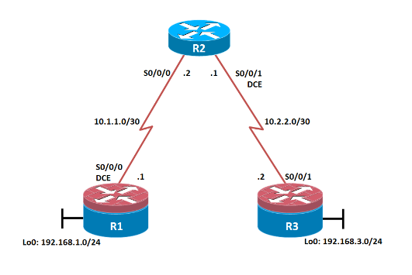**Secure the Management Plane**

**Topology:**

**Objectives:-**

* + Secure management access.
  + Configure enhanced username password security.
  + Enable AAA RADIUS authentication.
  + Enable secure remote management.

**Step 1: Prepare the routers for the lab.**

**Cable the network as shown in the topology diagram. Erase the startup configuration and reload each routerto clear previous configurations.**

**Step 2: Configure the hostname and interface addresses.**

1. **Copy and paste the following configurations into your routers to begin.Router R1**

**Router R1 (hostname SanJose)**

hostname SanJose

!

interface Loopback0

ip address 10.1.1.1 255.255.255.0

!

interface Serial0/0/0

ip address 192.168.1.5 255.255.255.252

clock rate 128000

no shutdown

**Router R2 (hostname ISP)**

hostname ISP

!

interface Loopback0

ip address 10.2.2.1 255.255.255.0

!

interface Serial0/0/0

ip address 192.168.1.6 255.255.255.252

no shutdown

!

interface Serial0/0/1

ip address 172.24.1.17 255.255.255.252

clock rate 128000

no shutdown

**Router R3 (hostname CustRtr)**

hostname CustRtr

!

interface Loopback0

ip address 10.3.3.1 255.255.255.0

!

interface Serial0/0/1

ip address 172.24.1.18 255.255.255.252

no shutdown

**Step 3: Configure BGP.**

1. **Configure BGP for normal operation. Enter the appropriate BGP commands on each router so that they**

SanJose(config)# **router bgp 100**

SanJose(config-router)# **neighbor 192.168.1.6 remote-as 300**

SanJose(config-router)# **network 10.1.1.0 mask 255.255.255.0**

ISP(config)# **router bgp 300**

ISP(config-router)# **neighbor 192.168.1.5 remote-as 100**

ISP(config-router)# **neighbor 172.24.1.18 remote-as 65000**

ISP(config-router)# **network 10.2.2.0 mask 255.255.255.0**

CustRtr(config)# **router bgp 65000**

CustRtr(config-router)# **neighbor 172.24.1.17 remote-as 300**

CustRtr(config-router)# **network 10.3.3.0 mask 255.255.255.0**

1. **Verify that these routers have established the appropriate neighbor relationships by issuing the show ip bgp neighbors command on each router.**

## ISP# show ip bgp neighbors

BGP neighbor is 172.24.1.18, remote AS 65000, external link

BGP version 4, remote router ID 10.3.3.1

BGP state = Established, up for 00:02:05

<output omitted>

BGP neighbor is 192.168.1.5, remote AS 100, external link

BGP version 4, remote router ID 10.1.1.1

BGP state = Established, up for 00:04:19

<output omitted>

**Step 4: Remove the private AS.**

1. **Display the SanJose routing table using the show ip route command. SanJose should have a route to both 10.2.2.0 and 10.3.3.0. Troubleshoot if necessary.**

SanJose# **show ip route**

Codes: C - connected, S - static, R - RIP, M - mobile, B - BGP

D - EIGRP, EX - EIGRP external, O - OSPF, IA - OSPF inter area N1 - OSPF NSSA external type 1, N2 - OSPF NSSA external type 2 E1 - OSPF external type 1, E2 - OSPF external type 2

i - IS-IS, su - IS-IS summary, L1 - IS-IS level-1, L2 - IS-IS level-2 ia - IS-IS inter area, * - candidate default, U - per-user static

route

o - ODR, P - periodic downloaded static route

Gateway of last resort is not set

10.0.0.0/24 is subnetted, 3 subnets

B 10.3.3.0 [20/0] via 192.168.1.6, 00:01:11

B 10.2.2.0 [20/0] via 192.168.1.6, 00:02:16

C 10.1.1.0 is directly connected,

Loopback0 192.168.1.0/30 is subnetted, 1 subnets

C 192.168.1.4 is directly connected, Serial0/0/0

1. **Ping the 10.3.3.1 address from SanJose.**

**Why does this fail?**

1. **Ping again, this time as an extended ping, sourcing from the Loopback0 interface address.**

SanJose# **ping**

Protocol [ip]:

Target IP address: 10.3.3.1

Repeat count [5]:

Datagram size [100]:

Timeout in seconds [2]:

Extended commands [n]: y

Source address or interface: 10.1.1.1

Type of service [0]:

Set DF bit in IP header? [no]:

Validate reply data? [no]:

Data pattern [0xABCD]:

Loose, Strict, Record, Timestamp, Verbose[none]:

Sweep range of sizes [n]:

Type escape sequence to abort.

Sending 5, 100-byte ICMP Echos to 10.3.3.1, timeout is 2 seconds:

Packet sent with a source address of 10.1.1.1

!!!!!

Success rate is 100 percent (5/5), round-trip min/avg/max = 16/65/96 ms

SanJose#

SanJose# **ping 10.3.3.1 source 10.1.1.1**

**Type escape sequence to abort.**

**Sending 5, 100-byte ICMP Echos to 10.3.3.1, timeout is 2 seconds:**

**Packet sent with a source address of 10.1.1.1**

**!!!!!**

**Success rate is 100 percent (5/5), round-trip min/avg/max = 24/45/52 ms**

**SanJose#**

1. **Check the BGP table from SanJose by using the show ip bgp command. Note the AS path for the 10.3.3.0 network. The AS 65000 should be listed in the path to 10.3.3.0.**

SanJose# **show ip bgp**

**BGP table version is 4, local router ID is 10.1.1.1**

**Status codes: s suppressed, d damped, h history, * valid, > best, i - internal,**

**r RIB-failure, S Stale, m multipath, b backup-path, f RT-Filter,**

**x best-external, a additional-path, c RIB-compressed,**

**Origin codes: i - IGP, e - EGP, ? - incomplete**

**RPKI validation codes: V valid, I invalid, N Not found**

**Network Next Hop Metric LocPrf Weight Path**

**\*> 10.1.1.0/24 0.0.0.0 0 32768 i**

**\*> 10.2.2.0/24 192.168.1.6 0 0 300 i**

**\*> 10.3.3.0/24 192.168.1.6 0 300 65000 i**

SanJose#

1. **Configure ISP to strip the private AS numbers from BGP routes exchanged with SanJose using the following commands.**

ISP(config)# **router bgp 300**

ISP(config-router)# **neighbor 192.168.1.5 remove-private-as**

1. **After issuing these commands, use the clear ip bgp * command on ISP to reestablish the BGP relationship between the three routers. Wait several seconds and then return to SanJose to check its routing table.**

SanJose should be able to ping 10.3.3.1 using its loopback 0 interface as the source of the ping.

SanJose# **ping 10.3.3.1 source lo0**

Type escape sequence to abort.

Sending 5, 100-byte ICMP Echos to 10.3.3.1, timeout is 2 seconds: Packet sent with a source address of 10.1.1.1

!!!!!

Success rate is 100 percent (5/5), round-trip min/avg/max = 28/28/32 ms

1. **Now check the BGP table on SanJose. The AS_ PATH to the 10.3.3.0 network should be AS 300. It no longer has the private AS in the path.**

SanJose# **show ip bgp**

BGP table version is 5, local router ID is 10.1.1.1

Status codes: s suppressed, d damped, h history, * valid, > best, i - internal,

r RIB-failure, S Stale, m multipath, b backup-path, f RT-Filter,

x best-external, a additional-path, c RIB-compressed,

Origin codes: i - IGP, e - EGP, ? - incomplete

RPKI validation codes: V valid, I invalid, N Not found

Network Next Hop Metric LocPrf Weight Path

*> 10.1.1.0/24 0.0.0.0 0 32768 i

*> 10.2.2.0/24 192.168.1.6 0 0 300 i

*> 10.3.3.0/24 192.168.1.6 0 300 i

SanJose#

**Step 5: Use the AS_PATH attribute to filter routes.**

1. **Configure a special kind of access list to match BGP routes with an AS_PATH attribute that both begins and ends with the number 100. Enter the following commands on ISP.**

ISP(config)# **ip as-path access-list 1 deny ^100$**

ISP(config)# **ip as-path access-list 1 permit .\***

1. **Apply the configured access list using the neighbor command with the filter-list option.**

ISP(config)# **router bgp 300**

ISP(config-router)# **neighbor 172.24.1.18 filter-list 1 out**

1. **Use the clear ip bgp * command to reset the routing information. Wait several seconds and then check the routing table for ISP. The route to 10.1.1.0 should be in the routing table.**

ISP# **show ip route**

<output omitted>

172.24.0.0/30 is subnetted, 1 subnets

C 172.24.1.16 is directly connected, Serial0/0/1 10.0.0.0/24 is subnetted, 3 subnets

B 10.3.3.0 [20/0] via 172.24.1.18, 00:07:34

C 10.2.2.0 is directly connected, Loopback0

192.168.1.0/30 is subnetted, 1 subnets

C 192.168.1.4 is directly connected, Serial0/0/0

1. **Check the routing table for CustRtr. It should not have a route to 10.1.1.0 in its routing table.**

CustRtr# **show ip route**

<output omitted>

172.24.0.0/30 is subnetted, 1 subnets

C 172.24.1.16 is directly connected, Serial0/0/1 10.0.0.0/24 is subnetted, 2 subnets

C 10.3.3.0 is directly connected, Loopback0

B 10.2.2.0 [20/0] via 172.24.1.17, 00:11:57

1. **Return to ISP and verify that the filter is working as intended. Issue the show ip bgp regexp ^100$ command.**

## I ISP# show ip bgp regexp ^100$

BGP table version is 4, local router ID is 10.2.2.1

Status codes: s suppressed, d damped, h history, * valid, > best, i – internal Origin codes: i - IGP, e - EGP, ? - incomplete

Network Next Hop Metric LocPrf Weight Path

*> 10.1.1.0 192.168.1.5 0 0 100 i

1. **Run the following Tcl script on all routers to verify whether there is connectivity. All pings from ISP should be successful. SanJose should not be able to ping the CustRtr loopback 10.3.3.1 or the WAN link**

iISP# **tclsh**

**foreach address { 10.1.1.1**

**10.2.2.1**

**10.3.3.1**

**192.168.1.5**

**192.168.1.6**

**172.24.1.17**

**172.24.1.18**

**} {**

**ping $address }**

**Router Interface Summary Table:**



**Practical No: 06**

**Configure and Verify Path Control Using PBR**

**Topology:**

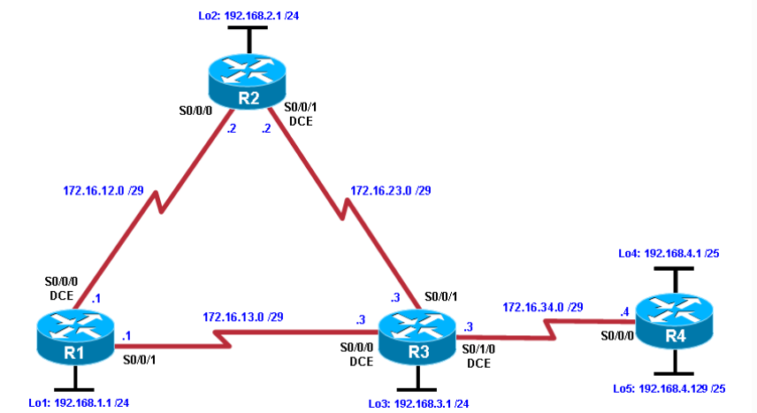

**Objectives:**

• Configure and verify policy-based routing.

• Select the required tools and commands to configure policy-based routing operations. • Verify the configuration and operation by using the proper show and debug commands.

**Step 1: Prepare the routers for the lab.**

Cable the network as shown in the topology diagram. Erase the startup configuration, and

reload each router to clear previous configurations.

**Step 2: Configure router hostname and interface addresses.**

1. Using the addressing scheme in the diagram, create the loopback interfaces and apply IP

addresses to these and the serial interfaces on R1, R2, R3, and R4. On the serial interfaces

connecting R1 to R3 and R3 to R4, specify the bandwidth as 64 Kb/s and set a clock rate on the

DCE using the clock rate 64000 command. On the serial interfaces connecting R1 to R2 and R2 to R3, specify the bandwidth as 128 Kb/s and set a clock rate on the DCE using the clock rate 128000 command.

You can copy and paste the following configurations into your routers to begin.

**Router R1**

hostname R1

interface Lo1

description R1 LAN

ip address 192.168.1.1 255.255.255.0

interface Serial4/0

description R1 --> R2

ip address 172.16.12.1 255.255.255.248

clock rate 128000

bandwidth 128

no shutdown

interface Serial4/1

description R1 --> R3

ip address 172.16.13.1 255.255.255.248

bandwidth 64

no shutdown

end

**Router R2**

hostname R2

interfaceLo2 description R2 LAN

ip address 192.168.2.1 255.255.255.0

interface Serial4/0

description R2 --> R1

ip address 172.16.12.2 255.255.255.248

bandwidth 128

no shutdown

interface Serial4/1

description R2 --> R3

ip address 172.16.23.2 255.255.255.248

clock rate 128000

bandwidth 128

no shutdown

end

**Router R3**

hostname R3

interface Lo3

description R3 LAN ip address 192.168.3.1 255.255.255.0

interface Serial4/0

description R3 --> R1

ip address 172.16.13.3 255.255.255.248

clock rate 64000

bandwidth 64

no shutdow

interface Serial4/1

description R3 --> R2

ip address 172.16.23.3 255.255.255.248

bandwidth 128

no shutdown

interface Serial4/2

description R3 --> R4

ip address 172.16.34.3 255.255.255.248

clock rate 64000

bandwidth 64

no shutdown

end

**Router R4**

hostname R4

interface Lo4

description R4 LAN A

ip address 192.168.4.1 255.255.255.128

interface Lo5

description R4 LAN B

ip address 192.168.4.129 255.255.255.128

interface Serial4/0

description R4 --> R3

ip address 172.16.34.4 255.255.255.248

bandwidth 64

no shutdown

end

1. **Verify the configuration with the show ip interface brief, show protocols, and show interfaces description commands. The output from router R3 is shown here as an example.**

R3# **show ip interface brief**

Interface IP-Address OK? Method Status

Protocol

FastEthernet0/0 unassigned YES unset administratively down down

FastEthernet1/0 unassigned YES unset administratively down down

FastEthernet2/0 unassigned YES unset administratively down down

FastEthernet2/1 unassigned YES unset administratively down down

GigabitEthernet3/0 unassigned YES unset administratively down down

Serial4/0 172.16.13.3 YES manual up up

Serial4/1 172.16.23.3 YES manual up up

Serial4/2 172.16.34.3 YES manual up up

Serial4/3 unassigned YES unset administratively down down

Serial4/4 unassigned YES unset administratively down down

Serial4/5 unassigned YES unset administratively down down

Serial4/6 unassigned YES unset administratively down down

Serial4/7 unassigned YES unset administratively down down

Loopback0 unassigned YES unset up up

Loopback3 192.168.3.1 YES manual up up

R3#**show protocols**

Global values:

Internet Protocol routing is enabled

FastEthernet0/0 is administratively down, line protocol is down

FastEthernet1/0 is administratively down, line protocol is down

FastEthernet2/0 is administratively down, line protocol is down

FastEthernet2/1 is administratively down, line protocol is down

GigabitEthernet3/0 is administratively down, line protocol is down

Serial4/0 is up, line protocol is up

Internet address is 172.16.13.3/29

Serial4/1 is up, line protocol is up

Internet address is 172.16.23.3/29

Serial4/2 is up, line protocol is up

Internet address is 172.16.34.3/29

Serial4/3 is administratively down, line protocol is down

Serial4/4 is administratively down, line protocol is down

Serial4/5 is administratively down, line protocol is down

Serial4/6 is administratively down, line protocol is down

Serial4/7 is administratively down, line protocol is down

Loopback0 is up, line protocol is up

Loopback3 is up, line protocol is up

Internet address is 192.168.3.1/24

R3# **show interfaces description**

Interface Status Protocol Description

Fa0/0 admin down down

Fa1/0 admin down down

Fa2/0 admin down down

Fa2/1 admin down down

Gi3/0 admin down down

Se4/0 up up R3 --> RI

Se4/1 up up R3 --> R2

Se4/2 up up R3 --> R4

Se4/3 admin down down

Se4/4 admin down down

Se4/5 admin down down

Se4/6 admin down down

Se4/7 admin down down

Lo0 up up

Lo3 up up R3 LAN

**Step 3: Configure basic EIGRP.**

**a. Implement EIGRP AS 1 over the serial and loopback interfaces as you have configured it for the other EIGRP labs.**

**b. Advertise networks 172.16.12.0/29, 172.16.13.0/29, 172.16.23.0/29, 172.16.34.0/29, 192.168.1.0/24, 192.168.2.0/24, 192.168.3.0/24, and 192.168.4.0/24 from their respective routers.**

You can copy and paste the following configurations into your routers.

**Router R1**

router eigrp network 192.168.1.0

network 172.16.12.0 0.0.0.7

network 172.16.13.0 0.0.0.7

no auto-summary

**Router R2**

router eigrp 1

network 192.168.2.0

network 172.16.12.0 0.0.0.7

network 172.16.23.0 0.0.0.7

no auto-summary

**Router R3**

router eigrp 1

network 192.168.3.0

network 172.16.13.0 0.0.0.7

network 172.16.23.0 0.0.0.7

network 172.16.34.0 0.0.0.7

no auto-summary

**Router R4**

router eigrp 1

network 192.168.4.0

network 172.16.34.0 0.0.0.7

no auto-summary

**Step 4: Verify EIGRP connectivity.**

1. **Verify the configuration by using the show ip eigrpneighborscommand**

**to check which routers have EIGRP adjacencies**

R1# **show ip eigrp neighbors**

EIGRP-IPv4 Neighbors for AS(1)

H Address Interface Hold Uptime SRTT RTO QSeq

(sec) (ms) Cnt Num

1 172.16.13.3 Se4/1 12 00:03:29 63 2340 0 15

0 172.16.12.2 Se4/0 13 00:05:23 48 11700 13

R2# **show ip eigrp neighbors**

EIGRP-IPv4 Neighbors for AS(1)

H Address Interface Hold Uptime SRTT RTO Q Seq

(sec) (ms) Cnt Num

1 172.16.23.3 Se4/1 12 00:03:55 48 1170 0 14

0 172.16.12.1 Se4/0 12 00:06:19 52 1170 0 14

R3# **show ip eigrp neighbors**

EIGRP-IPv4 Neighbors for AS(1)

H Address Interface Hold Uptime SRTT RTO Q Seq

(sec) (ms) CntNum

2 172.16.34.4 Se4/2 14 00:02:28 67 2340 0 3

1 172.16.23.2 Se4/1 14 00:04:22 45 1170 0 12

0 172.16.13.1 Se4/0 11 00:04:52 36 2340 0 13

R4# **show ip eigrp neighbors**

EIGRP-IPv4 Neighbors for AS(1)

H Address Interface Hold Uptime SRTT RTO Q Seq

(sec) (ms) Cnt Num

1. 172.16.34.3Se4/0 13 00:03:33 40 2280 0 15
2. **Run the following Tcl script on all routers to verify full connectivity.**

R1# **tclsh**

**foreach address {**

R1(tcl)#foreach address {

+>(tcl)#172.16.12.1

+>(tcl)#172.16.2

+>(tcl)#172.16.13.1

+>(tcl)#172.16.13.3

+>(tcl)#172.16.23.2

+>(tcl)#172.16.23.3

+>(tcl)#172.16.34.3

+>(tcl)#172.16.34.4

+>(tcl)#192.168.1.1

+>(tcl)#

+>(tcl)#192.168.2.1

+>(tcl)#192.168.3.1

+>(tcl)#192.168.4.1

+>(tcl)#192.168.4.129

+>(tcl)#} { ping $address }

You should get ICMP echo replies for every address pinged. Make sure to run the Tcl script on each router.

**Step 5: Verify the current path.**

1. **On R1, use the show ip route command. Notice the next-hop IP address for all networks discovered by EIGRP.**

R1# **show ip route**

Codes: L - local, C - connected, S - static, R - RIP, M - mobile, B - BGP

D - EIGRP, EX - EIGRP external, O - OSPF, IA - OSPF inter area

N1 - OSPF NSSA external type 1, N2 - OSPF NSSA external type 2

E1 - OSPF external type 1, E2 - OSPF external type 2

i - IS-IS, su - IS-IS summary, L1 - IS-IS level-1, L2 - IS-IS level-2

ia - IS-IS inter area, * - candidate default, U - per-user static route

o - ODR, P - periodic downloaded static route, H - NHRP, l - LISP

+ - replicated route, % - next hop override

Gateway of last resort is not set

172.16.0.0/16 is variably subnetted, 6 subnets, 2 masks

C 172.16.12.0/29 is directly connected, Serial4/0

L 172.16.12.1/32 is directly connected, Serial4/0

C 172.16.13.0/29 is directly connected, Serial4/1

L 172.16.13.1/32 is directly connected, Serial4/1

D 172.16.23.0/29 [90/21024000] via 172.16.12.2, 00:09:12, Serial4/0

D 172.16.34.0/29 [90/41024000] via 172.16.13.3, 00:08:41, Serial4/1

192.168.1.0/24 is variably subnetted, 2 subnets, 2 masks

C 192.168.1.0/24 is directly connected, Loopback1

L 192.168.1.1/32 is directly connected, Loopback1

D 192.168.2.0/24 [90/20640000] via 172.16.12.2, 00:09:11, Serial4/0

D 192.168.3.0/24 [90/21152000] via 172.16.12.2, 00:09:11, Serial4/0

192.168.4.0/25 is subnetted, 2 subnets

D 192.168.4.0 [90/41152000] via 172.16.13.3, 00:07:17, Serial4/1

D 192.168.4.128 [90/41152000] via 172.16.13.3, 00:07:17, Serial4/1

1. **On R4, use the traceroute command to the R1 LAN address and source the ICMP packet from R4 LAN A and LAN B.**

R4# **traceroute 192.168.1.1 source 192.168.4.1**

Type escape sequence to abort.

Tracing the route to 192.168.1.1

VRF info: (vrf in name/id, vrf out name/id)

1. 172.16.34.3 76 msec 24 msec 28 msec
2. 172.16.23.2 32 msec 52 msec 64 msec
3. 172.16.12.1 92 msec 72 msec 72 msec

R4#**traceroute 192.168.1.1 source 192.168.4.1**

Type escape sequence to abort.

Tracing the route to 192.168.1.1

VRF info: (vrf in name/id, vrf out name/id)

1. 1 172.16.34.3 96 msec 88 msec 20 msec

2 172.16.23.2 52 msec 44 msec 88 msec

3 3172.16.12.1 72 msec 76 msec 72 msec

R4#**traceroute 192.168.1.1 source 192.168.4.129**

Type escape sequence to abort.

Tracing the route to 192.168.1.1

VRF info: (vrf in name/id, vrf out name/id)

1. 172.16.34.3 80 msec 12 msec 40 msec
2. 172.16.13.1 32 msec 56 msec 60 msec
3. **On R3, use the show ip route command and note that the preferred route from R3 to R1 LAN 192.168.1.0/24 is via R2 using the R3 exit interface S0/0/1.**

R3# **show ip route**

Codes: L - local, C - connected, S - static, R - RIP, M - mobile, B - BGP

D - EIGRP, EX - EIGRP external, O - OSPF, IA - OSPF inter area

N1 - OSPF NSSA external type 1, N2 - OSPF NSSA external type 2

E1 - OSPF external type 1, E2 - OSPF external type 2

i - IS-IS, su - IS-IS summary, L1 - IS-IS level-1, L2 - IS-IS level-2

ia - IS-IS inter area, * - candidate default, U - per-user static route

o - ODR, P - periodic downloaded static route, H - NHRP, l - LISP

+ - replicated route, % - next hop override

Gateway of last resort is not set

172.16.0.0/16 is variably subnetted, 7 subnets, 2 masks

D 172.16.12.0/29 [90/21024000] via 172.16.23.2, 00:11:44, Serial4/1

C 172.16.13.0/29 is directly connected, Serial4/0

L 172.16.13.3/32 is directly connected, Serial4/0

C 172.16.23.0/29 is directly connected, Serial4/1

L 172.16.23.3/32 is directly connected, Serial4/1

C 172.16.34.0/29 is directly connected, Serial4/2

L 172.16.34.3/32 is directly connected, Serial4/2

D 192.168.1.0/24 [90/21152000] via 172.16.23.2, 00:11:44, Serial4/1

D 192.168.2.0/24 [90/20640000] via 172.16.23.2, 00:11:44, Serial4/1

192.168.3.0/24 is variably subnetted, 2 subnets, 2 masks

C 192.168.3.0/24 is directly connected, Loopback3

L 192.168.3.1/32 is directly connected, Loopback3

192.168.4.0/25 is subnetted, 2 subnets

D 192.168.4.0 [90/40640000] via 172.16.34.4, 00:09:49, Serial4/2

D 192.168.4.128 [90/40640000] via 172.16.34.4, 00:09:49, Serial4/2

1. On R3, use the show interfaces serial 0/0/0 and show interfaces s0/0/1 commands.

R3#**show interfaces s4/0**

Serial4/0 is up, line protocol is up

Hardware is M8T-X.21

Description: R3 --> RI

Internet address is 172.16.13.3/29

MTU 1500 bytes, BW 64 Kbit/sec, DLY 20000 usec,

reliability 255/255, txload 1/255, rxload 1/255

Encapsulation HDLC, crc 16, loopback not set

Keepalive set (10 sec)

Restart-Delay is 0 secs

Last input 00:00:02, output 00:00:02, output hang never

Last clearing of "show interface" counters never

Input queue: 0/75/0/0 (size/max/drops/flushes); Total output drops: 0

Queueing strategy: weighted fair

Output queue: 0/1000/64/0 (size/max total/threshold/drops)

Conversations 0/1/256 (active/max active/max total)

Reserved Conversations 0/0 (allocated/max allocated)

Available Bandwidth 48 kilobits/sec

5 minute input rate 0 bits/sec, 0 packets/sec

5 minute output rate 0 bits/sec, 0 packets/sec

492 packets input, 35766 bytes, 0 no buffer

Received 227 broadcasts (0 IP multicasts)

0 runts, 0 giants, 0 throttles

0 input errors, 0 CRC, 0 frame, 0 overrun, 0 ignored, 0 abort

442 packets output, 32832 bytes, 0 underruns

0 output errors, 0 collisions, 2 interface resets

0 unknown protocol drops

0 output buffer failures, 0 output buffers swapped out

2 carrier transitions DCD=up DSR=up DTR=up RTS=up CTS=up

R3#**show interfaces s4/1**

Serial4/1 is up, line protocol is up

Hardware is M8T-X.21

Description: R3 --> R2

Internet address is 172.16.23.3/29

MTU 1500 bytes, BW 128 Kbit/sec, DLY 20000 usec,

reliability 255/255, txload 1/255, rxload 1/255

Encapsulation HDLC, crc 16, loopback not set

Keepalive set (10 sec)

Restart-Delay is 0 secs

Last input 00:00:00, output 00:00:04, output hang never

Last clearing of "show interface" counters never

Input queue: 0/75/0/0 (size/max/drops/flushes); Total output drops: 0

Queueing strategy: weighted fair

Output queue: 0/1000/64/0 (size/max total/threshold/drops)

Conversations 0/1/256 (active/max active/max total)

Reserved Conversations 0/0 (allocated/max allocated)

Available Bandwidth 96 kilobits/sec

5 minute input rate 0 bits/sec, 0 packets/sec

5 minute output rate 0 bits/sec, 0 packets/sec

441 packets input, 31576 bytes, 0 no buffer

Received 221 broadcasts (0 IP multicasts)

0 runts, 0 giants, 0 throttles

0 input errors, 0 CRC, 0 frame, 0 overrun, 0 ignored, 0 abort

421 packets output, 30237 bytes, 0 underruns

0 output errors, 0 collisions, 1 interface resets

0 unknown protocol drops

0 output buffer failures, 0 output buffers swapped out

2 carrier transitions DCD=up DSR=up DTR=up RTS=up CTS=up

R3#**show ip eigrp topology 192.168.1.0**

EIGRP-IPv4 Topology Entry for AS(1)/ID(192.168.3.1) for 192.168.1.0/24

State is Passive, Query origin flag is 1, 1 Successor(s), FD is 21152000

Descriptor Blocks:

172.16.23.2 (Serial4/1), from 172.16.23.2, Send flag is 0x0

Composite metric is (21152000/20640000), route is Internal

Vector metric:

Minimum bandwidth is 128 Kbit

Total delay is 45000 microseconds

Reliability is 255/255

Load is 1/255

Minimum MTU is 1500

Hop count is 2

Originating router is 192.168.1.1

172.16.13.1 (Serial4/0), from 172.16.13.1, Send flag is 0x0

Composite metric is (40640000/128256), route is Internal

Vector metric:

Minimum bandwidth is 64 Kbit

Total delay is 25000 microseconds

Reliability is 255/255

**Step 6: Configure PBR to provide path control.**

**a. router R3, create a standard access list called PBR-ACL to identify the R4**

R3(config-std-nacl)# remark ACL matches R4 LAN B traffic

R3(config-std-nacl)# permit 192.168.4.128 0.0.0.127

R3(config-std-nacl)# exi

1. **Create a route map called R3-to-R1 that matches PBR-ACL and sets the**

**next-hop interface to the R1 serial 0/0/1 interface.**

R3(config**)# route-map R3-to-R1 permit**

R3(config-route-map)# **match ip address PBR-ACL**

R3(config-route-map)# **set ip next-hop 172.16.13.1**

R3(config-route-map)# **exit**

1. **Apply the R3-to-R1 route map to the serial interface on R3 that receives the traffic from R4. Use the ip policy route-map command on interface S0/1/0.**

R3(config)# **interface s0/1/0**

R3(config-if)# **ip policy route-map R3-to-R1**

R3(config-if)# **end**

1. **On R3, display the policy and matches using the show route-map command.**

R3# **show route-map**

route-map R3-to-R1, permit, sequence 10

Match clauses:

ip address (access-lists): PBR-ACL

Set clauses:

ip next-hop 172.16.13.1

Policy routing matches: 0 packets, 0 bytes

**Step 7: Test the policy.**

1. **On R3, create a standard ACL which identifies all of the R4 LANs.**

R3# **conf t**

Enter configuration commands, one per line. End with CNTL/Z.

R3(config)# **access-list 1 permit 192.168.4.0 0.0.0.255**

R3(config)# **exit**

1. **Enable PBR debugging only for traffic that matches the R4 LANs**.

R3# **debug ip policy ?**

<1-199> Access dynamic list

dynamic PBR

<cr>

R3# **debug ip policy 1**

Policy routing debugging is on for access list 1

1. **Test the policy from R4 with the traceroute command, using R4 LAN A as**

**the source network.**

R4# **traceroute 192.168.1.1 source 192.168.4.1**

Type escape sequence to abort.

Tracing the route to 192.168.1.1

1 172.16.34.3 0 msec 0 msec 4 msec

1. 172.16.23.2 0 msec 0 msec 4 msec
2. 3 172.16.12.1 4 msec 0 msec

R3#

Feb 23 07:07:46.467: IP: s=192.168.4.129 (Serial0/1/0), d=192.168.1.1, l

e n 28, policy match

Feb 23 07:07:46.467: IP: route map R3-to-R1, item 10, permit

*Feb 23 07:07:46.467: IP: s=192.168.4.129 (Serial0/1/0), d=192.168.1.1 (Se

rial0/0/0), len 28, policy routed

*Feb 23 07:07:46.467: IP: Serial0/1/0 to Serial0/0/0 172.16.13.1

*Feb 23 07:07:55.471: IP: s=192.168.4.129 (Serial0/1/0), d=192.168.1.1, le

n 28, policy match

*Feb 23 07:07:55.471: IP: route map R3-to-R1, item 10, permit

*Feb 23 07:07:55.471: IP: s=192.168.4.129 (Serial0/1/0), d=192.168.1.1 (Se

rial0/0/0), len 28, policy routed

*Feb 23 07:07:55.471: IP: Serial0/1/0 to Serial0/0/0 172.16.13.1

*Feb 23 07:07:55.471: IP: s=192.168.4.129 (Serial0/1/0), d=192.168.1.1, le

n 28, policy match

*Feb 23 07:07:55.471: IP: route map R3-to-R1, item 10, permit

*Feb 23 07:07:55.475: IP: s=192.168.4.129 (Serial0/1/0), d=192.168.1.1 (Se

rial0/0/0), len 28, policy routed

*Feb 23 07:07:55.475: IP: Serial0/1/0 to Serial0/0/0 172.16.13.1

*Feb 23 07:07:55.475: IP: s=192.168.4.129 (Serial0/1/0), d=192.168.1.1, le

n 28, FIB policy match \

*Feb 23 07:07:55.475: IP: s=192.168.4.129 (Serial0/1/0), d=192.168.1.1, g=

172.16.13.1, len 28, FIB policy routed

*Feb 23 07:08:04.483: IP: s=192.168.4.129 (Serial0/1/0), d=192.168.1.1, le

n 28, FIB policy match

*Feb 23 07:08:04.483: IP: s=192.168.4.129 (Serial0/1/0), d=192.168.1.1, g=

172.16.13.1, len 28, FIB policy routed

*Feb 23 07:08:04.491: IP: s=192.168.4.129 (Serial0/1/0), d=192.168.1.1, le

n 28, FIB policy match

*Feb 23 07:08:04.491: IP: s=192.168.4.129 (Serial0/1/0), d=192.168.1.1, g=

172.16.13.1, len 28, FIB policy routed

1. **On R3, display the policy and matches using the show route-map command.**

R3#

Feb 23 07:07:46.467: IP: s=192.168.4.129 (Serial0/1/0), d=192.168.1.1, l

e n 28, policy match

Feb 23 07:07:46.467: IP: route map R3-to-R1, item 10, permit

*Feb 23 07:07:46.467: IP: s=192.168.4.129 (Serial0/1/0), d=192.168.1.1 (Se

rial0/0/0), len 28, policy routed

*Feb 23 07:07:46.467: IP: Serial0/1/0 to Serial0/0/0 172.16.13.1

*Feb 23 07:07:55.471: IP: s=192.168.4.129 (Serial0/1/0), d=192.168.1.1, le

n 28, policy match

*Feb 23 07:07:55.471: IP: route map R3-to-R1, item 10, permit

*Feb 23 07:07:55.471: IP: s=192.168.4.129 (Serial0/1/0), d=192.168.1.1 (Se

rial0/0/0), len 28, policy routed

*Feb 23 07:07:55.471: IP: Serial0/1/0 to Serial0/0/0 172.16.13.1

*Feb 23 07:07:55.471: IP: s=192.168.4.129 (Serial0/1/0), d=192.168.1.1, le

n 28, policy match

*Feb 23 07:07:55.471: IP: route map R3-to-R1, item 10, permit

*Feb 23 07:07:55.475: IP: s=192.168.4.129 (Serial0/1/0), d=192.168.1.1 (Se

rial0/0/0), len 28, policy routed

*Feb 23 07:07:55.475: IP: Serial0/1/0 to Serial0/0/0 172.16.13.1

*Feb 23 07:07:55.475: IP: s=192.168.4.129 (Serial0/1/0), d=192.168.1.1, le

n 28, FIB policy match \

*Feb 23 07:07:55.475: IP: s=192.168.4.129 (Serial0/1/0), d=192.168.1.1, g=

172.16.13.1, len 28, FIB policy routed

*Feb 23 07:08:04.483: IP: s=192.168.4.129 (Serial0/1/0), d=192.168.1.1, le

n 28, FIB policy match

*Feb 23 07:08:04.483: IP: s=192.168.4.129 (Serial0/1/0), d=192.168.1.1, g=

172.16.13.1, len 28, FIB policy routed

*Feb 23 07:08:04.491: IP: s=192.168.4.129 (Serial0/1/0), d=192.168.1.1, le

n 28, FIB policy match

*Feb 23 07:08:04.491: IP: s=192.168.4.129 (Serial0/1/0), d=192.168.1.1, g=

172.16.13.1, len 28, FIB policy routed

1. **On R3, display the policy and matches using the show route-map command.**

R3# show route-map

route-mapR3-to-R1, permit, sequence 10 Match clauses:

ip address (access-lists): PBR-ACL

Set clauses:

ip next-hop 172.16.13.1

Policy routing matches: 12 packets, 384 bytes

**Note:** There are now matches to the policy because packets matching the ACL have passed through R3

S0/1/0.

# PracticalNo:.07

**IP Service Level Agreements and Remote SPAN in a CampusEnvironment.**

**Design:**



# Steps:

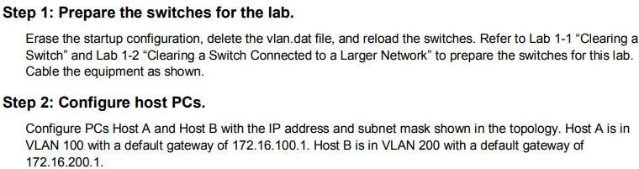

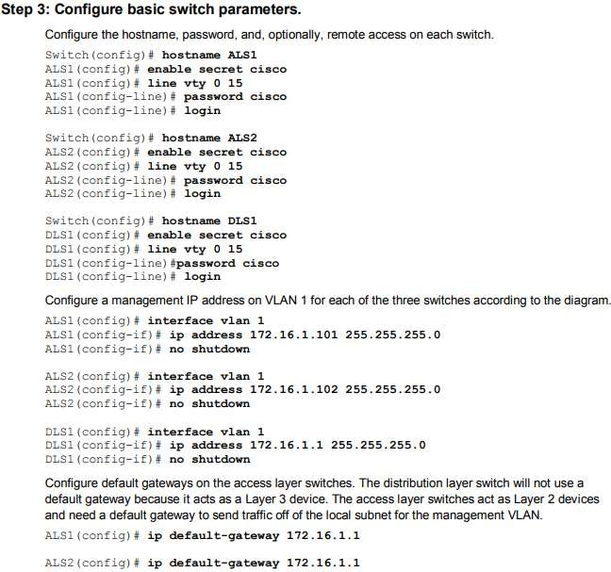

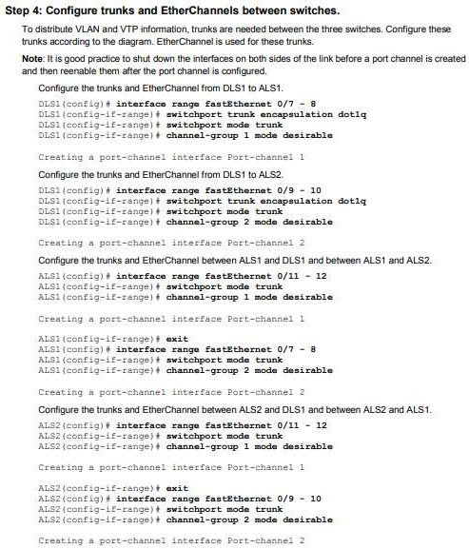

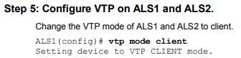

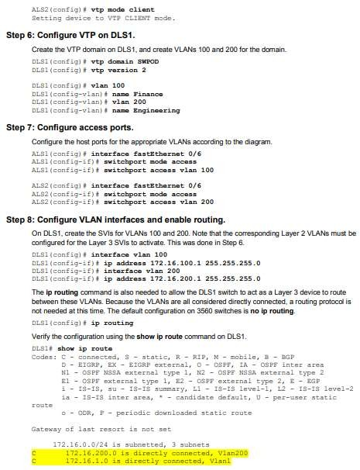

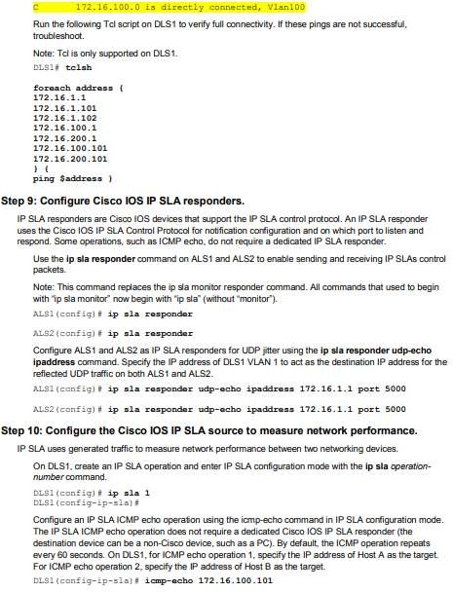

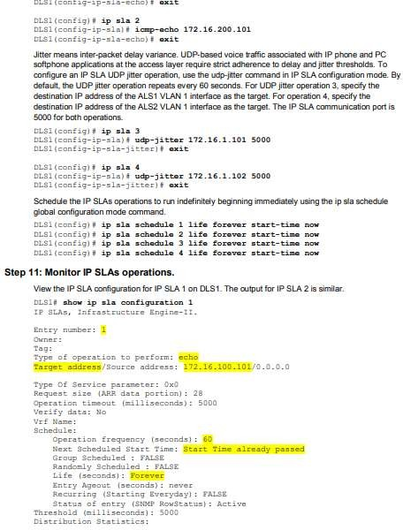

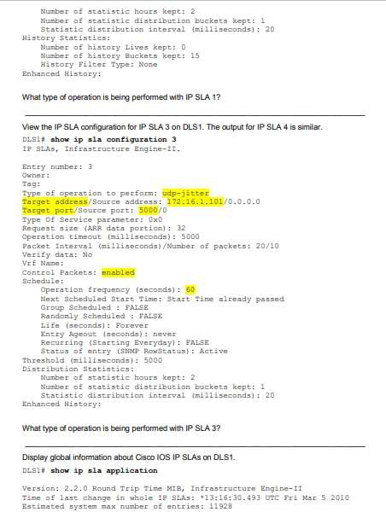

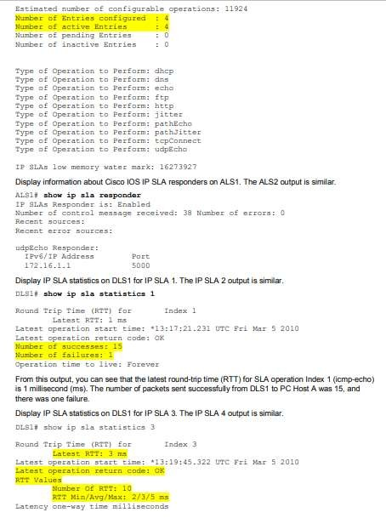

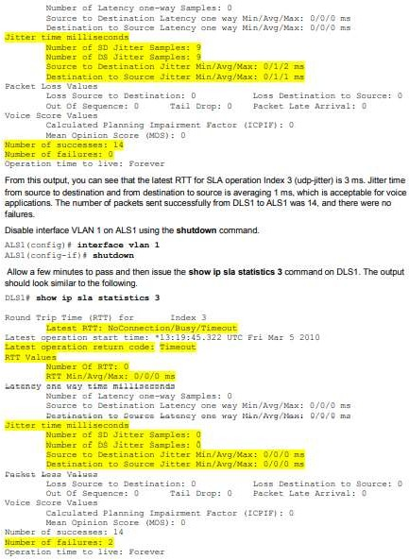

# PracticalNo:.08

# Inter-VlanRouting.

**Design:**



**PC0:**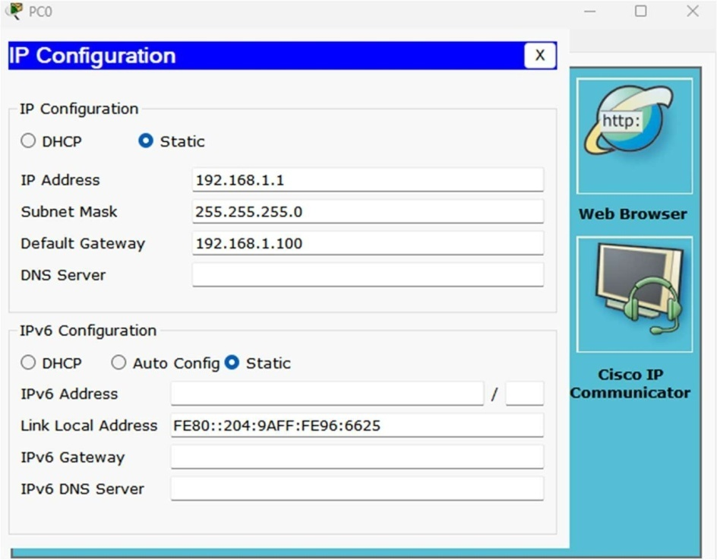

**PC1:**

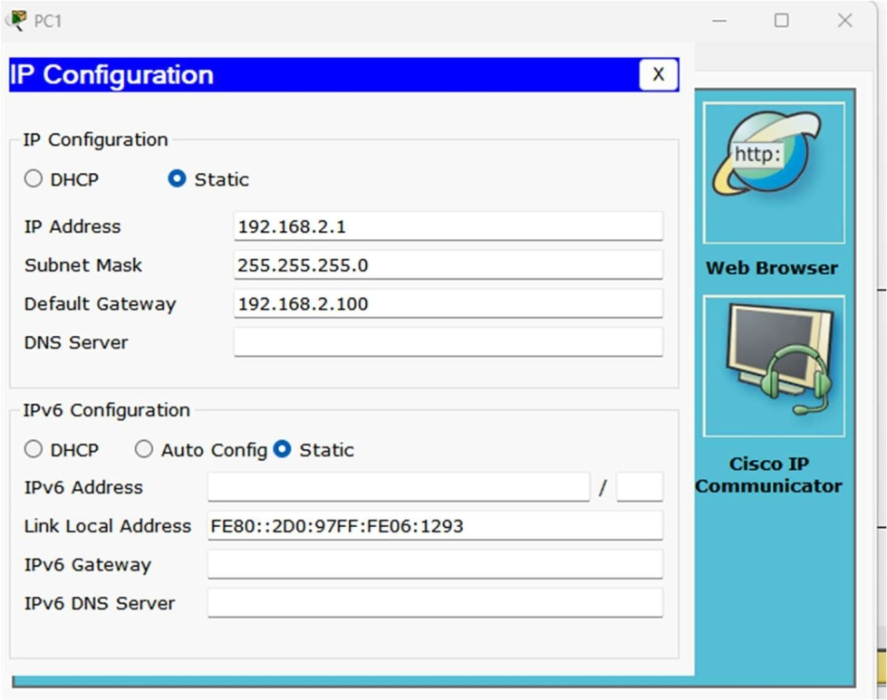

**PC2:**

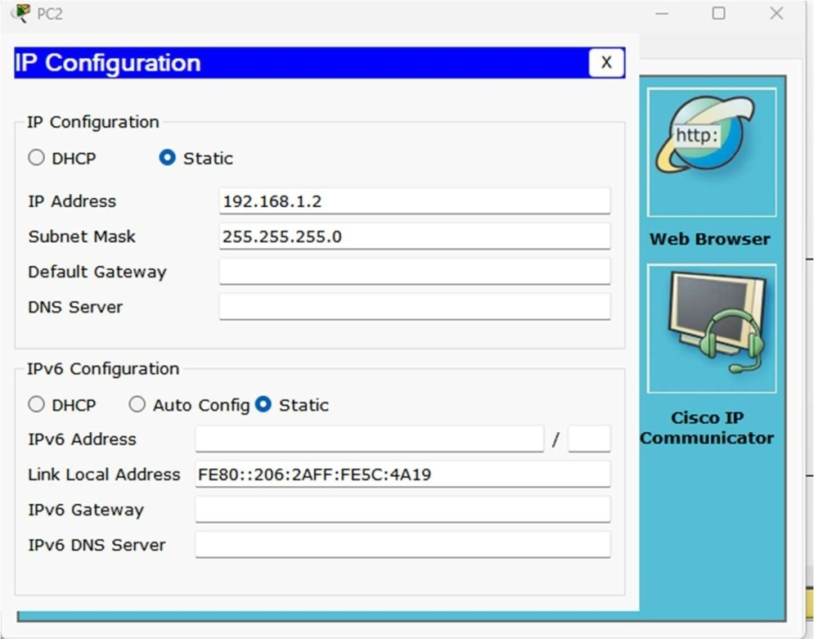

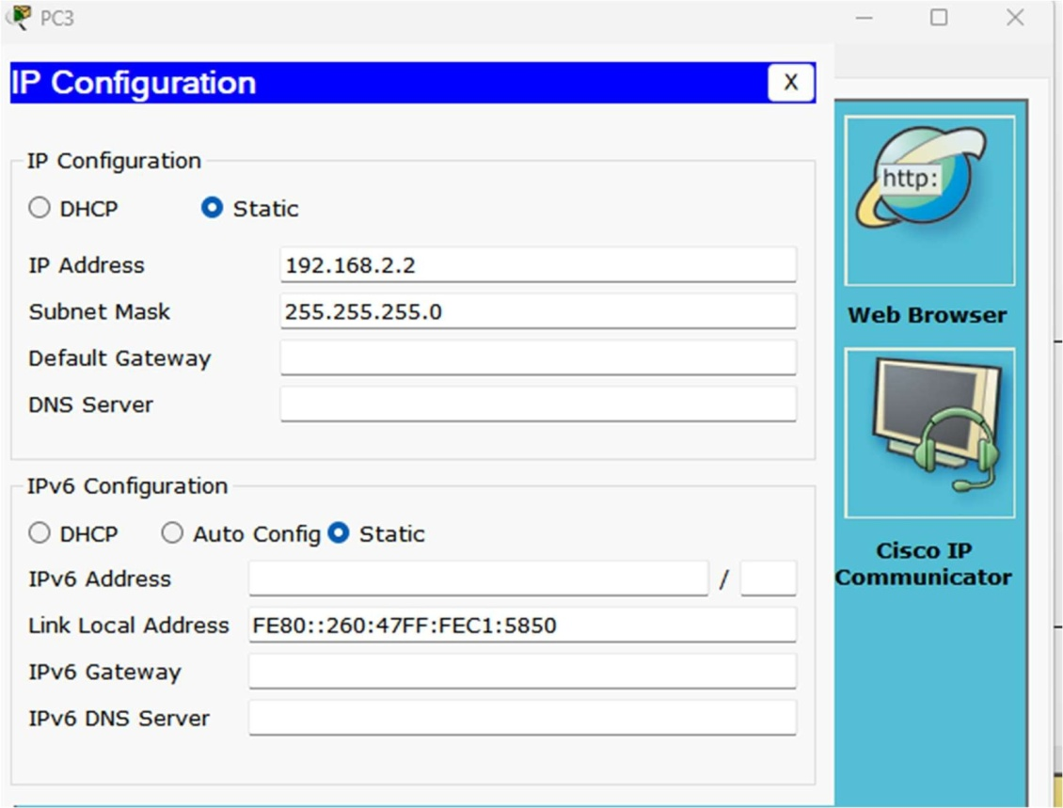**PC3:**

**CMD PC0:**

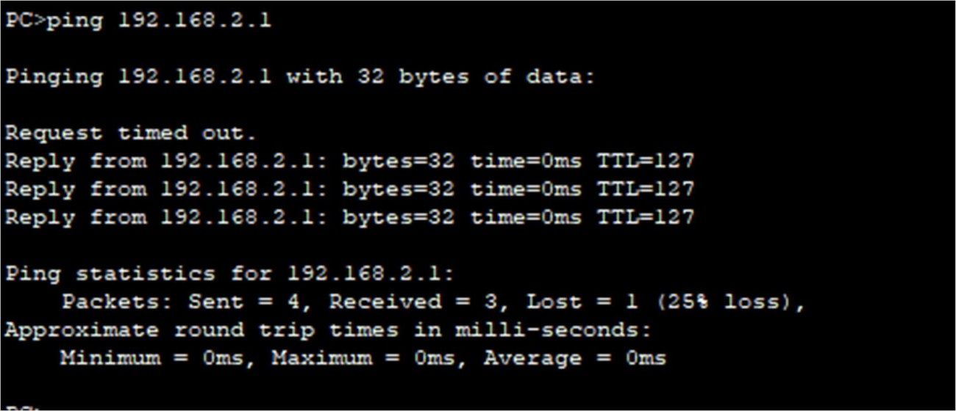

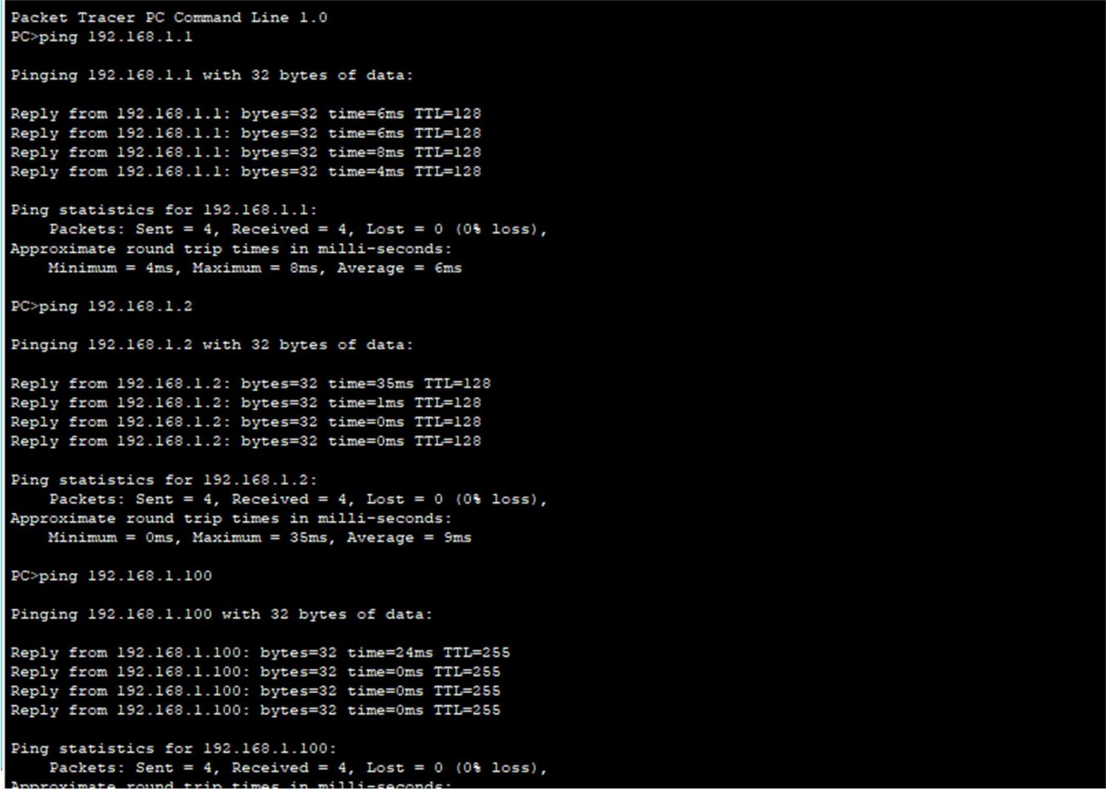**CMD PC1:**

**Practical No.: 09**

Configuring Basic MPLS Using OSPF

**Topology:**

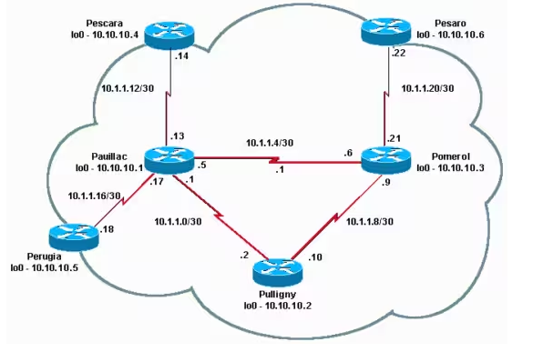

**Step 1:- Pomerol**

version 12.2

!

hostname Pomerol

!

ip subnet-zero

!

**ip cef**

!

interface Loopback0

ip address 10.10.10.3 255.255.255.255

!

interface Serial2/0

ip address 10.1.1.21 255.255.255.252

**tag-switching ip**

!

interface Serial3/0

ip address 10.1.1.6 255.255.255.252

**tag-switching ip**

!

interface Serial4/0

ip address 10.1.1.9 255.255.255.252

**tag-switching ip**

!

router ospf 10

log-adjacency-changes

network 10.0.0.0 0.255.255.255 area 9

!

ip classless

!

End

**Step 2:- Pulligny**

!

version 12.2

!

hostname Pulligny

!

!

ip subnet-zero

!

**ip cef**

!

interface Loopback0

ip address 10.10.10.2 255.255.255.255

!

interface Serial2/0

ip address 10.1.1.2 255.255.255.252

**tag-switching ip**

!

interface Serial3/0

ip address 10.1.1.10 255.255.255.252

**tag-switching ip**

!

router ospf 10

log-adjacency-changes

network 10.0.0.0 0.255.255.255 area 9

!

ip classless

!

end

**Step 3:- Pauillac**

!

version 12.2

!

hostname Pauillac

!

ip subnet-zero

!

**ip cef**

!

interface Loopback0

ip address 10.10.10.1 255.255.255.255

!

interface Serial2/0

ip address 10.1.1.13 255.255.255.252

**tag-switching ip**

!

interface Serial3/0

ip address 10.1.1.17 255.255.255.252

**tag-switching ip**

!

interface Serial4/0

ip address 10.1.1.1 255.255.255.252

**tag-switching ip**

!

interface Serial5/0

ip address 10.1.1.5 255.255.255.252

**tag-switching ip**

!

router ospf 10

log-adjacency-changes

network 10.0.0.0 0.255.255.255 area 9

!

ip classless

!

end

**Step 4:- Pescara**

!

version 12.2

!

hostname Pescara

!

ip subnet-zero

!

**ip cef**

!

interface Loopback0

ip address 10.10.10.4 255.255.255.255

!

interface Serial2/0

ip address 10.1.1.14 255.255.255.252

**tag-switching ip**

!

router ospf 10

log-adjacency-changes

network 10.0.0.0 0.255.255.255 area 9

!

ip classless

!

end

**Step 5:- Pesaro**

!

version 12.2

!

hostname Pesaro

!

ip subnet-zero

!

**ip cef**

!

interface Loopback0

ip address 10.10.10.6 255.255.255.255

!

interface Serial2/0

ip address 10.1.1.22 255.255.255.252

**tag-switching ip**

!

router ospf 10

log-adjacency-changes

network 10.0.0.0 0.255.255.255 area 9

!

ip classless

!

end

**Step 6:- Perugia**

!

version 12.2

!

hostname Perugia

!

ip subnet-zero

!

**ip cef**

!

interface Loopback0

ip address 10.10.10.5 255.255.255.255

!

interface Serial2/0

ip address 10.1.1.18 255.255.255.252

**tag-switching ip**

!

router ospf 10

log-adjacency-changes

network 10.0.0.0 0.255.255.255 area 9

!

ip classless

!

End

**Verify**

This section provides information you can use to confirm your configuration works properly.

Commands used in the [Configuring Basic MPLS Using IS-IS](https://www.cisco.com/en/US/tech/tk436/tk428/technologies_configuration_example09186a0080093fcc.shtml) sample configuration are also applicable.

In order to illustrate this sample configuration, look at a particular destination, for example **10.10.10.4**, on the **Pomerol** LSR.

Certain **show** commands are supported by the [Output Interpreter Tool](https://www.cisco.com/cgi-bin/Support/OutputInterpreter/home.pl) ([registered](https://tools.cisco.com/RPF/register/register.do) customers only) , which allows you to view an analysis of **show** command output.

[show ip route](https://www.cisco.com/en/US/docs/ios/12_3/switch/command/reference/swi_s2.html#wp1057479)—Used to check the IP route for this destination in the IP routing table:

Pomerol#**show ip route 10.10.10.4**

Routing entry for 10.10.10.4/32

Known via "ospf 10", distance 110, metric 129, type intra area

Last update from 10.1.1.5 on Serial3/0, 17:29:23 ago

Routing Descriptor Blocks:

* 10.1.1.5, from 10.10.10.4, 17:29:23 ago, via **Serial3/0**

Route metric is 129, traffic share count is 1

[show mpls forwarding-table](https://www.cisco.com/en/US/docs/ios/12_3/switch/command/reference/swi_s4.html#wp1069488)—Used to check the MPLS forwarding table, which is the label switching equivalent of the IP routing table for standard IP routing. It contains inbound and outbound labels and descriptions of the packets.

Pomerol#**show mpls forwarding-table**

Local Outgoing Prefix Bytes tag Outgoing Next Hop

tag tag or VC or Tunnel Id switched interface

16 Pop tag 10.1.1.12/30 636 Se3/0 point2point

17 Pop tag 10.10.10.1/32 0 Se3/0 point2point

**18 21 10.10.10.4/32 0 Se3/0 point2point**

19 Pop tag 10.1.1.0/30 0 Se4/0 point2point

Pop tag 10.1.1.0/30 0 Se3/0 point2point

20 Pop tag 10.10.10.6/32 612 Se2/0 point2point

21 Pop tag 10.1.1.16/30 0 Se3/0 point2point

22 16 10.10.10.5/32 0 Se3/0 point2point

23 Pop tag 10.10.10.2/32 0 Se4/0 point2point

[show mpls forwarding-table detail](https://www.cisco.com/en/US/docs/ios/12_3/switch/command/reference/swi_s4.html#wp1069488)—Used to see MPLS forwarding table details:

Pomerol#**show mpls forwarding-table 10.10.10.4 32 detail**

Local Outgoing Prefix Bytes tag Outgoing Next Hop

tag tag or VC or Tunnel Id switched interface

16 Pop tag 10.1.1.12/30 636 Se3/0 point2point

17 Pop tag 10.10.10.1/32 0 Se3/0 point2point

**18** **21** **10.10.10.4/32 0 Se3/0 point2point**

19 Pop tag 10.1.1.0/30 0 Se4/0 point2point

Pop tag 10.1.1.0/30 0 Se3/0 point2point

20 Pop tag 10.10.10.6/32 612 Se2/0 point2point

21 Pop tag 10.1.1.16/30 0 Se3/0 point2point

22 16 10.10.10.5/32 0 Se3/0 point2point

23 Pop tag 10.10.10.2/32 0 Se4/0 point2point

MAC/Encaps=4/8, MRU=1500, Tag Stack{21}

0F008847 00015000

No output feature configured

Per-packet load-sharing

[show mpls ldp bindings](https://www.cisco.com/en/US/docs/ios/12_3/switch/command/reference/swi_s4.html#wp1066851)or [show tag-switching tdp bindings](https://www.cisco.com/en/US/docs/ios/12_3/switch/command/reference/swi_s5.html#wp1048394)(based on which Cisco IOS software release you use) —Used to see the label bindings associated with a particular destination. Both the local as well as the remote bindings can be seen.

Pomerol#**show tag-switching tdp bindings 10.10.10.4 32**

tib entry: 10.10.10.4/32, rev 14

local binding: tag: **18**

remote binding: tsr: 10.10.10.1:0, tag: **21**

remote binding: tsr: 10.10.10.2:0, tag: 23

remote binding: tsr: 10.10.10.6:612, tag: 20

Note that labels for each forwarding class are established at each LSR, even if they are not on the preferred (shortest) path. In this case, a packet destined to 10.10.10.4/32 can go by 10.10.10.1 (with label 21) or by 10.10.10.2 (with label 23). The LSR chooses the first solution because it is the shortest one. This decision is made with the standard IP routing table, which in this case, is built with OSPF.

[show ip cef detail](https://www.cisco.com/en/US/docs/ios/12_3/switch/command/reference/swi_s2.html)—Used to check that Cisco Express Forwarding works properly and that tags are swapped correctly:

Pomerol#**show ip cef 10.10.10.4 detail**

10.10.10.4/32, version 37, cached adjacency to Serial3/0

0 packets, 0 bytes

tag information set

local tag: **18**

fast tag rewrite with Se3/0, point2point, tags imposed: **{21}**

via 10.1.1.5, Serial3/0, 0 dependencies

next hop 10.1.1.5, Serial3/0

valid cached adjacency

tag rewrite with Se3/0, point2point, tags imposed: **{21}**

**PracticalNo:10**

* 1. **Open DaylightSDNControllerwiththe MininetNetworkEmulator.**

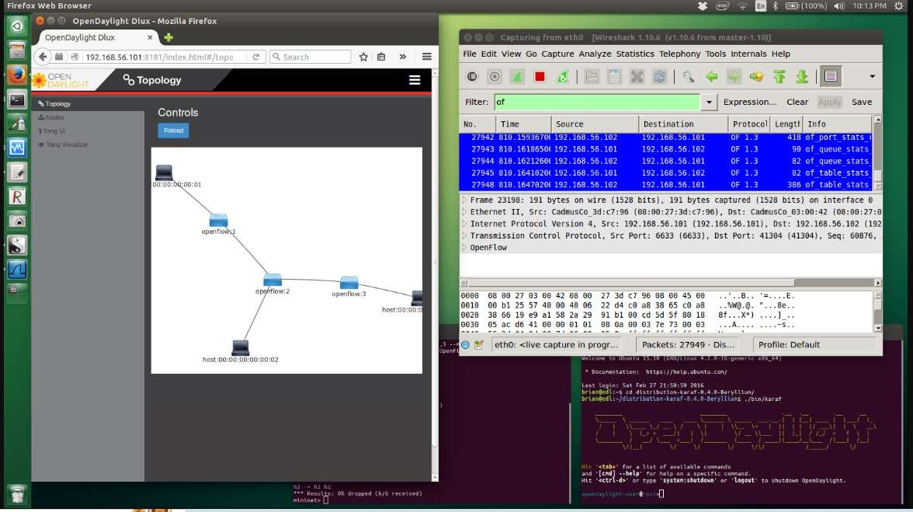**Design:**

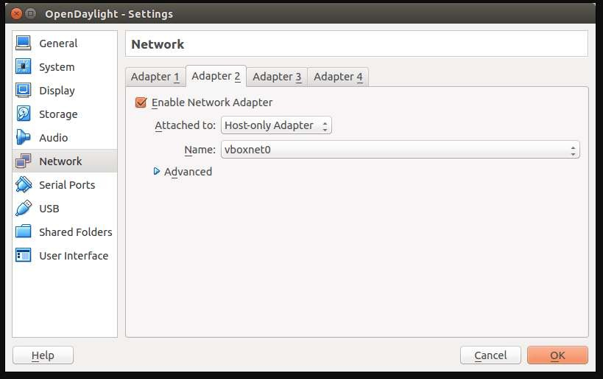

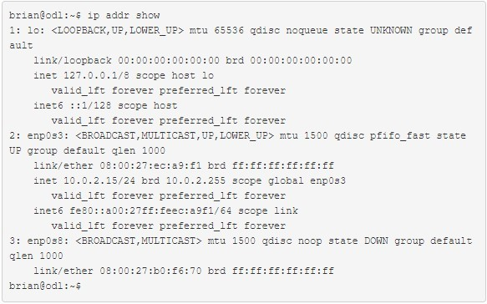

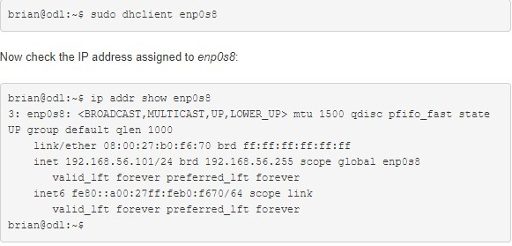

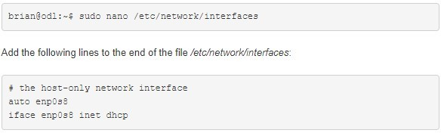

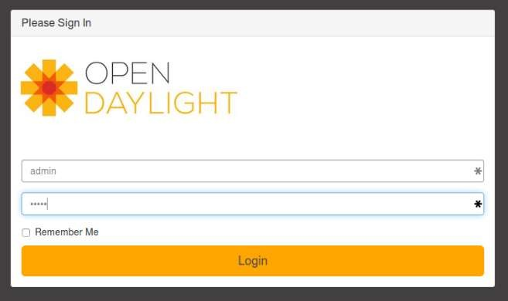

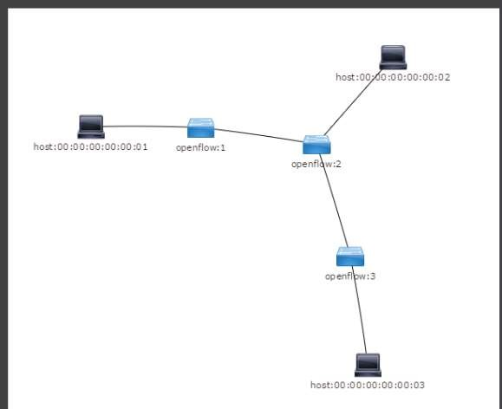

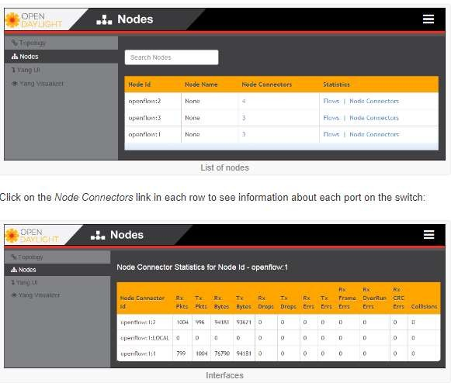

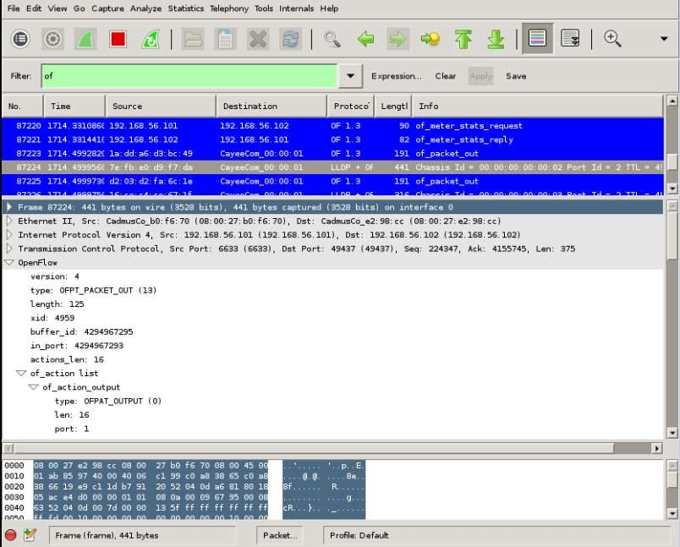

**10.B) OF-NetSDNnetworkemulator.**

